Assessing Egypt’s exposure to the EU CBAM and policy response options in light of recent EU implementing regulations

Contents
Summary 2
1 Introduction 2
2 Overview of the EU CBAM regulation and recent updates 4
2.1 Coverage and embedded emissions calculation 5
2.2 Carbon prices paid 7
3 Potential implications of the EU CBAM for Egypt 8
3.1 Egypt’s sectoral exposure to the EU CBAM 8
3.2 CBAM and future clean energy exports 17
3.3 Macroeconomic and trade implications for Egypt 18
3.4 Risks and opportunities from CBAM for Egypt 22
4 Policy options in view of CBAM and national objectives 23
4.1 CBAM provisions regarding carbon pricing in third countries 23
4.2 A range of policy options 25
4.3 Simulated policy outcomes for Egypt 29
4.4 Importance of complementary options for decarbonizing industry 37
5 Conclusion 38
6 Supplemental information 42
6.1 Global experience with carbon pricing 42
6.2 The interplay of carbon pricing with energy taxes and subsidies in Egypt 49
6.3 Practical pathways toward carbon pricing 52

Summary
The Egyptian economy faces important risks and also opportunities from the EU's Carbon Border Adjustment Mechanism (CBAM). Among the six covered sectors—aluminum, cement, electricity, fertilizers, hydrogen, and iron and steel—roughly two-fifths of Egyptian CBAM-sector exports go to the EU, with potential annual CBAM payments reaching USD 400 million by 2034. However, exposure ultimately depends less on the total obligations assessed than on the relative carbon-competitiveness of Egyptian firms in EU markets, and this varies considerably by sector. Iron and steel faces the highest risk due to the high default emission intensities assigned by the EU, while Egyptian fertilizer producers are relatively clean and could actually gain competitiveness if they document their actual emissions. At the macroeconomic level, the overall impact is projected to be modest — a roughly 0.2% reduction in GDP — though individual firms in highly exposed sectors face more specific risks—or potential gains if they are prepared.
Modeling of a range of policy scenarios reveals clear tradeoffs: broader carbon pricing delivers the largest domestic gains, while targeted industrial support best reduces CBAM exposure. A comprehensive carbon levy—covering both upstream emissions from fuel consumption and downstream industrial process emissions—achieves the most objectives, raising about $5.8 billion, cutting emissions by 41.6 MtCO₂, avoiding 1,656 premature deaths, and reducing CBAM obligations by 26.1%. Upstream carbon levies achieve similar economy-wide mitigation, revenues, and health gains but fewer CBAM obligation reductions, covering only part of CBAM-sector emissions. Downstream pricing of industrial point-source emissions is more targeted, and common rebating options forego fiscal revenues. Free allocation dilutes the carbon price signal and the carbon price effectively paid under CBAM, while a rebate toward industrial abatement achieves the largest CBAM-obligation reduction, at 30.4%. Overall, a sequenced strategy combining broad-based pricing with abatement-linked support for CBAM-exposed firms could best balance revenue, emissions reductions, competitiveness, and domestic co-benefits.
A robust Monitoring, Reporting, and Verification (MRV) system is a prerequisite for Egypt's exporters to demonstrate actual emission intensities, allowing them to avoid onerous default values and prove their carbon competitiveness. These measures should be paired with continued mitigation strategies, fossil fuel subsidy reform, and strategic use of concessional finance to accelerate industrial decarbonization over the longer term.

Introduction
As a major producer and exporter of emissions-intensive industrial goods, Egypt faces significant climate transition risks. The introduction of the EU Carbon Border Adjustment Mechanism (CBAM), which covers EU imports of aluminum, cement, electricity, fertilizers, hydrogen, and iron and steel, will likely affect a significant number of Egyptian exporting firms. The EU is the main and geographically natural destination for Egypt’s exports, including for this set of carbon-intensive products. Approximately 6 percent of Egypt's exports (by traded value) fall under the scope of the CBAM, and 49 percent of Egypt’s exports of CBAM products are destined to the EU. Other jurisdictions like the UK and Australia are also planning to implement their own border carbon adjustment mechanisms, signaling expanding global demand for low-carbon industrial goods and shrinking demand for emissions-intensive ones.
Some Egyptian exports of CBAM goods could face substantial carbon cost obligations in the EU. These costs heavily depend on several elements, including: (i) the amount of exports in CBAM-covered goods destined to the EU; (ii) declared embedded emissions in CBAM-covered goods, because higher carbon intensity will result in steeper CBAM charges; and (iii) the presence (or not) of a domestic direct carbon pricing instrument, which could be deducted from the CBAM obligations. Furthermore, administrative costs arising from the calculation and reporting of embedded emissions at the product level could add to the overall compliance costs. Without a domestic carbon price, Egyptian businesses could face annual CBAM-related payments of USD 400 million by 2034, when the mechanism is fully phased in. These funds could instead be retained domestically through the introduction of a carbon pricing instrument.
CBAM payments may result in some Egyptian exporters losing export competitiveness in the EU market, and some other Egyptian exporters gaining export competitiveness, depending on the emission intensity of firms in CBAM sectors. Those Egyptian firms with greater carbon emissions than EU producers will be subject to higher costs than many competitors when they enter the EU market, while those with lower emissions could gain competitiveness. Those firms that lose competitiveness will experience export and job losses and may require restructuring to lower emissions and remain competitive in the EU market. CBAM applies to individual firms, but looking at the default emission intensities applied and Egypt’s product-level trade data gives a useful indicator of potential exposure at the sector level. In the fertilizer, aluminum, and cement sectors, Egypt’s default emission intensity values are very similar to those of the average EU producer, meaning little change in relative competitiveness is expected. However, for iron and steel products, Egypt was assigned the default of “other countries”, which is much higher than that of average EU producers or of the large Egyptian production facilities, resulting in the sector being highly exposed. Egyptian steel producers that cannot or do not report and verify their actual emissions—including manufacturers that rely on imported steel precursor goods—will find themselves at a competitive disadvantage. In reality, most Egyptian steel and also fertilizer plants are less carbon intensive than global and many European counterparts, meaning they could gain competitiveness under CBAM—as long as they are able to document their emissions. For this reason—and with growing markups to default values expected—implementing robust monitoring, reporting, and verification systems in these industries will be critical to prospering under CBAM.
At the same time, the CBAM provisions allow for the deduction of carbon prices effectively paid in third countries, creating opportunities for countries that implement their own domestic carbon pricing instruments to keep emissions revenues at home and reduce payments to the EU. Carbon pricing instruments, like a carbon tax or emissions trading system (ETS), are market-based mechanisms used by many countries to reduce their GHG emissions. At present, 100 jurisdictions (regional, national and sub-national), including many developing countries, have already introduced direct carbon pricing instruments (World Bank, 2026), playing both central and supporting roles in achieving nationally determined contributions (NDC). Carbon pricing policies are attractive because they are economically efficient—leveraging financial incentives rather than mandating behavior—and because they can help achieve multiple objectives: fiscal consolidation, improved local air quality, transport-related co-benefits such as reduced congestion and fewer road accidents, and lower carbon growth, as well as reducing CBAM exposure.
The green transition is a critical priority for Egypt, driven by both domestic needs and international imperatives. Greener industries and infrastructure can create jobs, generate revenues, and support sustainable economic growth. Internationally, Egypt’s competitiveness and access to global markets increasingly depend on meeting rising environmental standards and climate commitments, as major trading partners and investors demand lower carbon footprints and compliance with mechanisms such as the EU CBAM. For Egypt, the green transition means reimagining its growth model to decouple economic development from high carbon and pollution intensity, ensuring long-term prosperity and resilience for its citizens while fulfilling its global commitments.
This note aims to address the request of the Government of Egypt to increase officials’ understanding of the implications of CBAM and support them in designing policies that help Egypt respond effectively to it. The paper is structured as follows. Section 2 provides an overview of the EU CBAM. Section 3 assesses the potential exposure of Egyptian sectors to CBAM and the role of improved data in identifying the degree of carbon-competitiveness or risks for firms and sectors. Section 4 reviews global experience with different forms of carbon pricing and analyzes policy options for Egypt to reduce exposure to CBAM, unlock low-carbon competitiveness, and retain carbon payments domestically. Section 5 concludes.

Overview of the EU CBAM regulation and recent updates
The CBAM is a climate policy designed to mirror the EU’s Emissions Trading Scheme (ETS) for industrial emitters that aims to reduce greenhouse gas (GHG) emissions by accounting for the carbon costs of certain imported goods. Its goal is to prevent carbon leakage, a potential consequence of the EU ETS, where industries with high GHG emissions relocate production to regions with less stringent climate policies or substitute domestic production with imports of high-carbon goods. The CBAM replaces the previous approach of providing free allowances to EU producers as a leakage-protection measure, now leveling the playing field at the border.
The CBAM applies to EU importers of specific industrial goods, who must declare and purchase CBAM certificates for different types of embedded emissions. Direct (Scope 1) emissions are the CO₂, nitrous oxide, and perfluorocarbon gases emitted during the production of industrial goods—either from the consumption of fuels or because of production processes; they are subject to CBAM for all specified goods in covered sectors. Indirect (Scope 2) emissions are those that arise from the generation of the electricity that is consumed during the production of industrial goods; they are accounted for in certain sectors. By requiring EU importers covered by the CBAM to purchase CBAM certificates for carbon dioxide equivalent (CO₂e) emissions not priced domestically, the mechanism aims to ensure that EU consumers pay for their embedded carbon equivalent, regardless of where the goods are produced. The idea is to level the playing field for businesses and create incentives for non-EU companies to reduce emissions. The CBAM applies to all non-EU countries in principle, though countries linked to the EU ETS are exempt.
The CBAM financial obligation now applies for imports into the EU starting 1 January 2026. From that date, imports of CBAM goods can only be made to the EU by a pre-authorized CBAM declarant (the importer), who will face a carbon price comparable to that paid by EU companies running installations covered by the EU ETS. Each authorized CBAM declarant will declare the embedded emissions (using actual or default emissions intensities) in CBAM goods imported into the EU during the previous calendar year to EU authorities and surrender CBAM certificates covering those emissions. Deductions will be made for qualifying direct carbon pricing payments made on those embedded emissions in a third country. The amount of the CBAM financial obligation will be gradually phased in during 2026 to 2034, reflecting the extent to which EU ETS allowances are allocated free of charge in installations producing CBAM goods within the EU.

Coverage and embedded emissions calculation
Currently, the CBAM covers carbon-intensive goods at high risk of carbon leakage: iron and steel, aluminum, fertilizers, cement, electricity, and hydrogen. Coverage applies to specific goods defined by tariff codes rather than entire sectors, meaning not all products from those industries are included. While direct emissions are covered for all sectors, cement and fertilizer have indirect emissions included as well.
Figure 1. CBAM product categories and emissions coverage
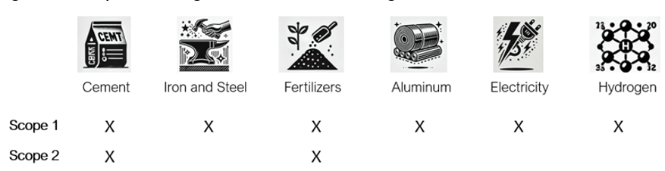

Source: World Bank staff based on Regulation (EU) 2023/956 of the European Parliament and of the Council of 10 May 2023 establishing a carbon border adjustment mechanism”, as amended by Regulation (EU) 2025/2083.
Coverage can be expected to expand over time; in December 2025 the EU Commission proposed extending coverage to approximately 180 downstream "complex goods"—including machinery, vehicle parts, and domestic appliances, where the parts of steel and aluminum will be covered by the CBAM financial obligation. The proposal is currently discussed by the EU legislators and changes are likely to be in force from 1 January 2028.
The starting point for calculating CBAM liabilities are "embedded emissions"—the GHG emissions released during production of a good. For non-electricity goods, importers may use either installation-level actual emissions—subject to stringent measurement, reporting, and verification (MRV) requirements—or default values. Default values were released by the Commission in December of 2025 for each product and country pair. Where country-specific values are not given, the default values of the “other countries” category will apply, and they are derived from the world’s most emission-intensive producers.
In practice, using actual emissions data requires facility-level data that is more granular than what most national MRV systems currently capture. Evidence from the transitional phase suggests that the majority of importers have relied on default rather than actual values, meaning many exporters—particularly in developing countries—face the higher-cost default route unless they invest in more rigorous emissions tracking and independent verification. Detailed methods for calculating the embedded emissions as well as applicable verification principles are laid down in Commission Implementing Regulations published in December 2025. These aim to mirror provisions applicable to stationary installations under the EU Emissions Trading Scheme, considering the further need for data applicable to individual CBAM goods. For electricity, embedded emissions follow a similar determination of country-specific defaults for grid-level emission intensity, although actual emissions can be established via a verified power purchase agreement meeting specific criteria. (See section 3.3.1).
CBAM obligations will be phased in gradually, in parallel with free allocations for EU producers decreasing between 2026 and 2034 and markups to CBAM default values for the emission intensity of other CBAM goods than electricity increasing between 2026 and 2028. First, to maintain symmetry with the treatment of EU producers, CBAM liabilities are reduced to reflect free allowances still allocated under the EU ETS. Benchmark allocations for each product are detailed in the implementing regulation and do not vary by country of origin, although they can vary by production route. As free allocations to EU producers are phased out between 2026 and 2034, the symmetric treatment blunts the full force of the CBAM obligations for a period of time. Second, importers using default values will face a phased mark-up, starting at 10% in 2026 and rising to 30% by 2028 (for fertilizers a lower mark-up of 1% is applied). The markup makes declaring actual emissions ever more important for lower-carbon producers to reduce CBAM financial obligations. The phase-in of CBAM gives trade partners some time to adjust; however, certain goods with relatively high default or actual emissions above the benchmarks may face a significant immediate CBAM financial impact.
A compliance threshold would exclude EU importers of small quantities of goods but does not necessarily exclude the goods of small exporters. The compliance threshold is based on an annual cumulative net mass per importer, set at 50 tons of weight of the goods. The EU claims that this threshold should greatly reduce the administrative burden while still ensuring that more than 99% of emissions are maintained in scope. From an exporter perspective, the CBAM obligations remain unless they are just trading small amounts to these small importers.
The CBAM introduces a significant new compliance burden for exporters to the EU, particularly in developing countries that may lack the capacity to document actual emissions and access more favorable certificate calculations. For this reason, a monitoring, reporting, and verification (MRV) strategy ought to be a first component of a CBAM response. It can also be an important step towards developing domestic capacity to implement and enforce home-grown regulations of emitting facilities, including with downstream carbon pricing.

Carbon prices paid
The CBAM financial obligation will reflect prevailing prices of EU ETS allowances, and deductions for carbon pricing effectively paid in a third country will ensure CBAM goods sold on EU markets face a consistent price. Importers must purchase CBAM certificates priced at the weekly average EU ETS allowance auction price, providing a direct and transparent link to the EU carbon market. However, importers can claim a reduction in CBAM certificates if they demonstrate that a direct carbon price (an ETS or carbon tax) was effectively paid in a third country, meaning monetary values paid net of exemptions and rebates. An importer claiming a reduction of the CBAM financial obligation due to a carbon price demonstrated to have been effectively paid in a third country needs to have used actual emissions data as the basis for the declaration of embedded emissions in the CBAM goods. From 2027, the EU Commission will publish default carbon price values for different third countries to simplify this process, though when embedded emissions themselves are based on default values, only these default carbon prices may be used to claim a reduction.
A draft Commission Implementing Regulation was presented in May 2026 with further details on how an effectively paid carbon price in a third country could be deductible by an importer from its CBAM financial obligation. The EU Commission was empowered by the CBAM legislation to, after consultation with EU Member States, set technical and administrative rules to ensure consistent application of the relevant carbon pricing rules. Note that the rules have yet to be finalized as of this report; the public consultation resulted in close to 200 comments from various stakeholders and the draft will be discussed through the summer of 2026 with the aim of finalizing the regulation in the fall.
Importers that declare their actual emissions will be able to choose between providing evidence of actual payment of a carbon price and an alternative approach. The alternative approach, intended to ease the administrative burden, will enable the importer to apply a yearly default embedded carbon price for the relevant third country. Importers relying on default emission intensities can only use this alternative approach. From 2027, the EU Commission will develop and publish default carbon prices for third countries with applicable policies, based on the best available data.
The draft regulation confirms that only payments made under direct (explicit) carbon pricing mechanisms are deductible and lays down methodology and procedure to verify what emissions are covered by the pricing and evidence of payment. Direct carbon pricing can be in the form of an upstream carbon fuel excise tax, a downstream tax at installation level (a point source carbon tax) or an emissions trading scheme. Payments for voluntary carbon credits as part of compliance with a domestic carbon pricing scheme can be recognized under certain conditions. Charges restricted to exports are excluded. Special attention is given to how different subsidies would affect the deductible price and restrictions are given on eligible subsidies to ensure that only effectively paid carbon prices are accounted for. Due to the ongoing discussions in the EU, the exact details of the provisions are at this stage not yet fully clear, which means that subsidies to producers of CBAM goods need to be designed carefully. Key implications from the draft rules are further discussed in Section 4.1.

Potential implications of the EU CBAM for Egypt

Egypt’s sectoral exposure to the EU CBAM
The exposure to the EU’s CBAM of Egyptian exporters in affected sectors will hinge on two main factors. First, the higher the CO₂ emissions intensity of exporting firms in a sector compared to the average EU firm in that sector, the greater the impact on the exporting firms as they will face higher carbon payments. The carbon payment per dollar of output, known as the carbon cost intensity, is determined by multiplying the price by the emission intensity. The difference in carbon cost intensities between the firm with respect to the EU average producer is referred to as relative carbon cost intensity. Second, a greater level of concentration of a firm’s exports towards the EU relative to the rest of the world will amplify the impact on the exporter. Consequently, a sector’s exposure to CBAM is dictated not only by the relative emission intensity of the firms in that sector but also by their export orientation. However, if Egypt establishes a direct carbon pricing scheme resulting in an effectively paid carbon price, EU importers will receive credits from the EU for those carbon payments that exporters made in Egypt and would only need to cover the difference if the CBAM payments exceed the payments made in Egypt.
We assess the exposure of Egyptian affected sectors using the CBAM trade exposure index (TEI), which measures a combination of trade dependence and relative emission intensity. A high positive TEI indicates that the affected sector in Egypt is likely to lose competitiveness in the EU market due to its higher carbon payments, and that a large share of its export market is at risk. Conversely, a negative index suggests that the Egyptian sector may gain competitiveness in the EU, as its carbon payments are lower than the EU average. Sectors that are less dependent on trade with the EU will have a smaller exposure number, positive or negative.
The current approach to calculating the TEI adopts now-available mass-based emissions intensity and trade data that are closely aligned with the CBAM policy, and the results contrast starkly with original World Bank CBAM TEI (from 2023 and updated in 2025), which relied on value-based emissions intensity and trade data. Figure 2 compares the results for Egypt (using 2022 trade data for comparability with the value-based study). The value-based TEI gave Egypt as highly exposed in fertilizers, iron and steel, and aluminum; due to little trade in cement, that exposure is lower. However, according to the mass-based approach, Egypt is minimally exposed in fertilizers, aluminum, and cement. Because the EU assigned country-specific defaults to these products—and found that the emissions intensities of the specific products are very similar to those of EU producers—the mass-based calculations are likely to be more accurate of actual exposure. Essentially, if Egypt is exporting products with lower value added and lower prices than EU ones, the value-based calculations will overestimate Egyptian emission intensity by weight relative to that of EU producers.
The CBAM Trade Exposure Index (TEI) is derived by multiplying two key factors: difference in emission intensity and trade dependence on the EU (see equation below). It is calculated by dividing the excess carbon payments—determined by a carbon price, the value of affected exports to the EU, and the difference between Egypt’s emissions intensity and the EU average in the affected sector—by the total value of the country’s global exports of the affected sector. The product of the price and the emission intensity denotes the carbon payment per dollar of output and can be referred to as the carbon-cost intensity. Excess carbon payments represent the total value of CBAM certificates in excess of the emissions costs of EU competitors for the value of exports for the affected sector.
$${CBAM TEI}_{c,s}= \overset{Relative carbon cost intensity}{\overbrace{\overset{\begin{matrix}{CO}_{2} \\ price\end{matrix}}{\overbrace{τ}}·\overset{\begin{matrix}difference from EU \\ emission intensity\end{matrix}}{\overbrace{\left({EI}_{c,s}-{EI}_{EU,s}\right)}}}}·\underset{\begin{matrix}EU trade \\ dependence\end{matrix}}{\underbrace{\frac{X_{c,s}^{EU}}{X_{c,s}^{World}}}}= \frac{\overset{excess carbon payments}{\overbrace{τ·({EI}_{c,s}-{EI}_{EI,s})·X_{c,s}^{EU}}}}{\underset{\begin{matrix}total trade in \\ the sector\end{matrix}}{\underbrace{X_{c,s}^{World}}}}$$
Where τ=CO₂ price, c = country, s = sector, X = exports, EI = emission intensity.
Different approaches can be taken to compute the index, based on the choice of trade and emissions intensity data sources. One follows the original cross-country analysis of the World Bank (Maliszewska et al. 2025), which combines emissions intensity per dollar of value from the GTAP database, an input-output approach widely used in numerical models, with trade data (also in monetary values) from the World Integrated Trade Solutions (WITS) database. These value-based data can be directly compared across countries, but essentially assume identical average emissions intensities per dollar across all products within the aggregated sector of a country. By contrast, a mass-based approach more closely follows the design of the CBAM: it takes the EU country- and product-specific default values to represent emission intensity by weight, and uses trade data in tons from BACI to calculate the carbon embodied in exports to the EU for each 6-digit covered product code, aggregating embedded carbon to the sector level. To compare to the embedded emissions in an average EU producer, weight-based emission intensities are taken for the EU from the Joint Research Center (JRC) database; the EU comparison is then calculated for the same composition of products in Egyptian exports. To calculate the CBAM trade exposure indexes, we use a USD 100 per metric ton of CO₂ equivalent for the certificate price and make additional assumptions that 1) the CBAM is fully phased in (no free benchmark allocations), 2) the defaults are indicative of mass-based emission intensities (no markups), and 3) trade patterns remain as in recent years. The total excess carbon payments, calculated by either method, are divided by the total value of product exports in the sector using the associated trade data.
Figure 2: CBAM TEIs by data approach (2022 trade data)

The new mass-based TEI does find significant exposure in one sector: iron and steel. However, for these products, the EU assigned to Egypt the “other countries” benchmark (noted with an asterisk in the figure). In this case, the default may not be an accurate indicator of the actual average emissions intensity of Egyptian-produced steel. (However, it may not be as inaccurate for steel products manufactured with imported raw steel or precursors).
Independent, third-party data indicate that Egyptian facilities are not global outliers, and Egyptian steel facilities are relatively clean, in contrast to the assigned default values. Climate Trace offers third-party data on emissions and production activity for major facilities worldwide. According to these data, Egyptian steel facilities have significantly lower emission factors than the global average (or the EU average of 1.19). Also in fertilizers, Egyptian facilities appear to be relatively clean compared to global peers. In the other sectors, Climate Trace estimates that Egyptian facilities are on average up to 20% more emissions intensive than the world average (Figure 3).
These differing insights based on different sources of average intensity data underscore the need for Egyptian exporters to document and verify their actual emissions intensities. Low-carbon producers have the opportunity to benefit from CBAM on EU markets—if they can demonstrate their carbon competitiveness.

Figure 3: Facility-level emission intensities from Climate Trace
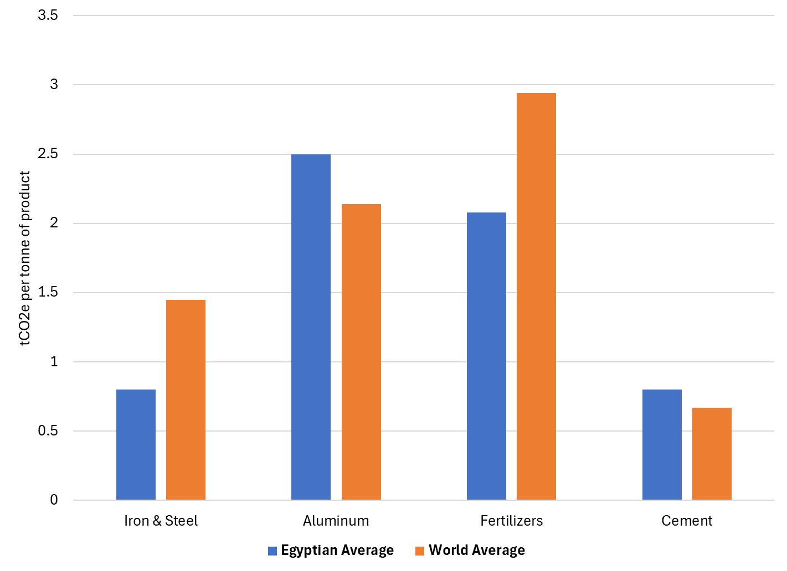

For the remainder of the report, the mass-based approach is used to estimate certificate obligations, and the trade data are updated to 2023, which is the last year of final (non-provisional) data in BACI. Though the EU will estimate CBAM certificate costs based on emissions at the firm level, estimates are based on data aggregated to the exported product and sector level, since data are not available at the firm level. The components of the resulting TEI are illustrated in Figure 4, and the calculated values by sector are given in Table 1.
Table 1: Sector-level trade in 2023 and ad valorem equivalent (AVE) carbon cost calculations
 | to EU27 |  | to World |  |  |  |  | Competitiveness change
EXPORTS | Quantities (weight) | Values | Values | EU trade share |  | AVE | Avg. EU cost | Competitiveness change
Fertilizers | 2,570,899 | M$ 1,244 | M$ 3,305 | 38% | 28.5% |  | 27.4% | -1.1%
Iron and Steel | 1,511,755 | M$ 1,178 | M$ 2,914 | 40% | 51.7% |  | 23.3% | -28.4%
Aluminium | 187,732 | M$ 521 | M$ 779 | 67% | 8.5% |  | 7.1% | -1.4%
Cement | 654,110 | M$ 60 | M$ 884 | 7% | 144.3% |  | 138.5% | -5.8%
Source: World Bank staff calculations, based on 2023 product-level trade data from BACI, default values for Egyptian goods, EU emission intensities from JRC (2023), and a presumed $100/tCO2e EU ETS price.
Figure 4: Components of the mass-based TEI (2023 trade data)
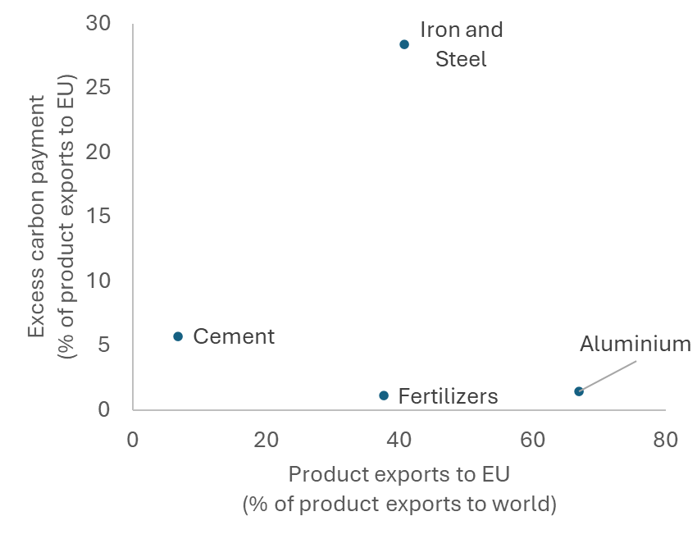
Source: World Bank staff calculations, based on 2023 product-level trade data from BACI, default values for Egyptian goods, EU emission intensities from JRC (2023), and a presumed $100/tCO2e EU ETS price.

Iron and Steel
Iron and steel appears to be Egypt’s most exposed sector in some metrics, but it may also have the greatest potential to benefit by reporting its actual emissions. In 2023, Egypt exported 1.5 million tons of covered steel products worth $1.2 billion to the EU, representing 40% of its total steel exports. Meanwhile, Egyptian steel products were assigned the relatively high “other countries” default values, resulting in an ad-valorem cost equivalent of 52%, more than twice that of the EU average producer. This combination indicates high exposure—unless Egyptian producers can document their actual emissions. Moreover, iron and steel products, with high default values, can face obligations for most of their emissions already this year. Figure 4 illustrates the implications of the phase-in for two types of producers of flat-rolled steel: one that has an emissions profile like EU producers (and verifies those actual emissions), and a second one that uses the default value assigned to it, in this case under the “Other countries” category. In 2026, an Egyptian producer that proves it is at least as clean as efficient EU producers would have nearly all of their CBAM liability on their exported goods offset by the free allocation adjustment; however, a producer that does not document its actual emissions intensity and relies on the default value will have obligations in excess of the benchmark. As the phase-in continues, the benchmark reductions decline and the markup penalty for using defaults increases over the next three years.
Figure 5: Components of total obligations (tCO2e/ton of product) under the CBAM phase-in: declared emissions intensity (by type of producers), markup, and residual benchmark under EU ETS free allowances phase-out (tCO2e/t of product)
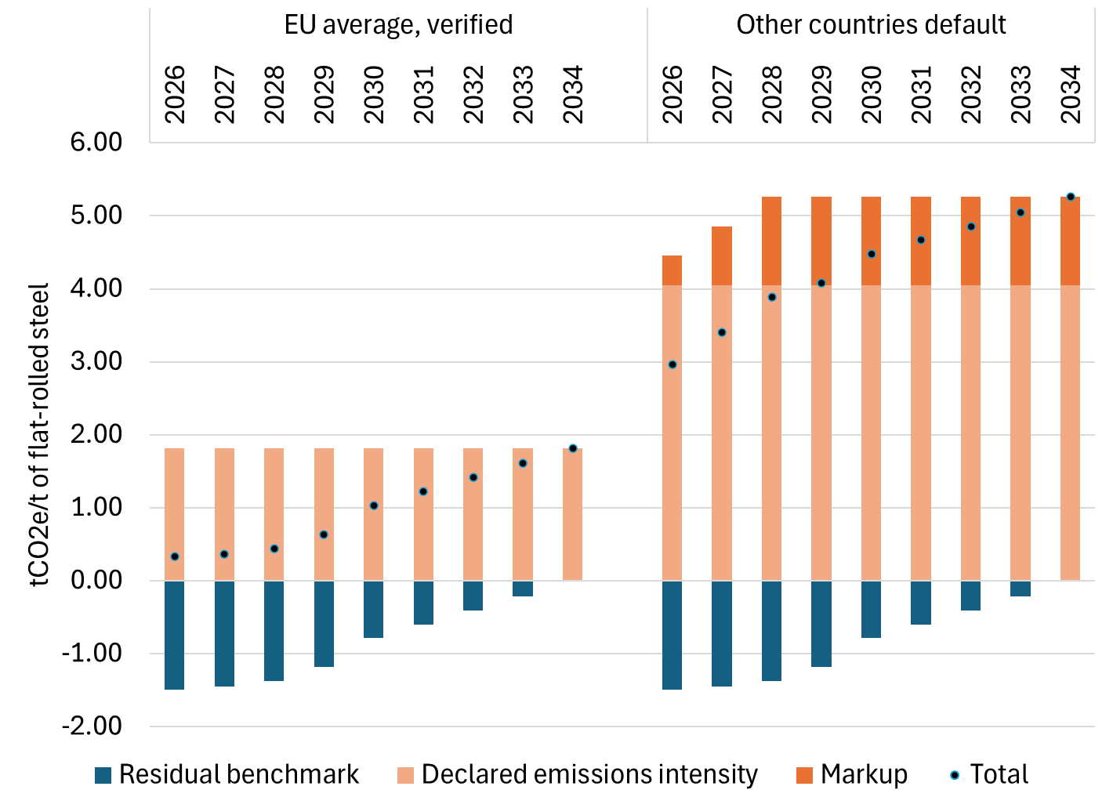
Source: Own calculations, based on default values and provisional benchmarks for flat-rolled steel (Product CN code 7208) as in the implementing regulation 2025/2621.

Evidence suggests that Egyptian primary iron and steel facilities are relatively less emissions intensive than its global counterparts (Figure 3). Indeed, according to Climate Trace, Egypt no longer has an operating blast furnace, the most emissions-intensive production route; of its 10 major steel plants, 6 rely on electric arc furnaces (EAF) and 4 a combination of direct reduction and EAF. The total annual production of crude steel is roughly 10 million tons.
Egyptian exporters of steel products are not necessarily relying domestic steel, and information about their size, numbers, or supply chains is lacking. In 2023, Egypt imported 14 million tons of CBAM-covered steel products—more than total domestic crude steel production and 9 times what was exported to the EU by weight. For this reason, the decision to apply “other countries” default values to Egyptian steel exports may not be surprising. There may be many Egyptian firms adding value to steel products using imported steel as inputs and exporting the result to the EU. In 2014 (the last year of data shared by Egypt in the Exporter Dynamics Database), there were over 500 firms exporting steel products, 77 of which had significant exports to the EU—an order of magnitude larger than the number of domestic production facilities. Although these data are old, they indicate that there may be many small or medium enterprises engaged in CBAM product trade with the EU.
Steel product producers that are downstream in the supply chain are likely to have more difficulty documenting and declaring their actual emissions than the major steel producers. For those relying on domestic steel as inputs, MRV by the major facilities can help improve the competitiveness of those downstream producers. For those relying on imported steel inputs, they will need reporting by their suppliers. The reliance on the EU for exports of finished steel products means that Egyptian producers seeking to compete will shift their demand for inputs to low-carbon suppliers, including domestic ones.

Aluminum
Although Egyptian exporters of aluminum products are highly dependent on EU trade, the CBAM costs are less pronounced for these goods than in other sectors. Egyptian aluminum producers exported about $0.5 billion in CBAM covered goods to the EU in 2023, roughly half the value of steel exports, but representing a full two-thirds of Egypt’s worldwide exports of these products. Given their default values (without markups), the ad valorem equivalent of the CBAM obligations would be 8.5%, as compared to 7.1% for an average EU producer. The result is only a slight competitiveness loss. Still, as markups to using defaults are phased in, documenting actual emissions will be important for maintaining competitiveness.
Egypt has a single aluminum smelter (the Nag Hammadi plant), which is presumed to have a typical emissions factor. New facilities are planned nearby to double capacity. A large production complex has also been proposed in the Suez Canal Economic Zone. Ensuring these new facilities are state-of-the-art also in terms of emissions intensity will help boost competitiveness in EU markets. Egypt also imports by weight roughly the same amount of aluminum as it exports to the EU, suggesting that precursor emissions will be relevant in this sector too.
Downstream firms are likely important for aluminum product exports as well, but not as significantly as for steel. A decade ago (for which data are available), Egypt reported about 200 firms exporting covered aluminum products, of which 34 were dependent on EU trade. Those firms also appeared to be larger, trading higher values annually compared to their steel-sector counterparts. It would be important to prepare these downstream firms to report based on their own emissions and those of their suppliers.

Fertilizers
For Egypt, fertilizers are the largest CBAM sector by mass or value of exports; however, Egyptian fertilizer producers are estimated to maintain or improve their competitiveness on EU markets. Egypt exported $1.2 billion in covered fertilizer products to the EU in 2023, or 38% of its? global exports—similar to scope and trade dependence as the steel sector. However, the ad valorem equivalent of the default embedded carbon costs of 28.5%, though substantial, is similar to the 27.4% of the average EU producer for the same product mix, resulting in a slight competitiveness disadvantage of 1.1%. Reporting actual emissions is likely to overcome this disadvantage.
As identified by Climate Trace, Egypt has 6 active fertilizer plants (ammonia producers), and their estimated emissions factors are significantly lower than the global average. This evidence suggests that Egyptian fertilizer producers could gain competitiveness in EU markets under with the CBAM implementation, if they can credibly document and verify their emissions.

Cement
Of the four main CBAM sectors, cement products are the least exposed for Egypt. They are the smallest by value—just $59 million in 2023, or one-tenth that of aluminum—and only 7% of exports go to the EU. The ad valorem equivalent of the embedded carbon costs is substantial—144%—but the EU average for those products would be a similar 139%, implying a cost difference of 6%.
Climate Trace identifies 26 facilities producing cement in Egypt, with a range of emission intensities depending on calcination factors and fuel sources for the type of cement, but the average is similar to the global average.

Other products that may be added
The European Commission is proposing to add roughly 180 steel- and aluminum-intensive downstream products to the list of CBAM goods. More products may be added during the legislative process in the EU. Examples include auto parts, machinery and industrial equipment, domestic appliances, and fabricated metals. If approved, these rules would take effect on January 1, 2028.
The total Egyptian exports of these listed products were valued at $284 million in 2023—or 17% of the value of aluminum and iron and steel exports. Specific default values are not yet available, but even if assigned the high emission intensity values of steel products by weight, the ad valorem equivalent would not exceed 10%. Since these downstream products have more value added, the carbon cost share and exposure risk tend to be lower than for primary products. Still, demonstrating the use of carbon-competitive inputs would help boost competitiveness for these products as well.

CBAM and future clean energy exports

Electricity
The electricity sector has important implications for trade with the EU under CBAM. First of all, it factors into the indirect emissions of certain CBAM goods—namely fertilizers and cement for now, but the scope may be expanded for other products in the future. At the moment, Egypt’s default emissions factor (0.442 tCO2eq/MWh) is less than that of the EU (0.612 tCO2eq/MWh), reflecting a grid that is dominated by natural gas. This default factor is similar to other third-party estimates of Egypt’s grid intensity; Ember, for example, gives 0.446 tCO2eq/MWh for 2024. Expansion of renewable energy could further reduce this number, and efficiency investments to improve the electricity intensity of the production of CBAM goods could further reduce their obligations.
Second, although Egypt does not currently export electricity as a good to the EU, it plans to do so in the future. Egypt is pursuing multiple interconnection projects with Greece/Cyprus and Italy, each with capacities of 2-3 GW and each allowing for up to 20-25 TWh of renewable energy exports annually. with the first starting around 2035. Egypt currently produces 250 TWh annually.
For greening Egyptian trade, a decision will need to be made whether to use new renewable energy capacity to lower the overall emissions intensity of the Egyptian grid, reducing the scope 2 emissions of manufacturing, or to dedicate it to EU electricity exports, maximizing the clean premium of those electricity sales, but leaving the grid factor largely unchanged. Under CBAM, electricity purchases (either as EU imports or as inputs to CBAM-covered goods) are assigned the average grid intensity, except under specific circumstances. To qualify as green electricity under CBAM under current rules, exports must be supported by power purchase agreements, physical interconnection, and hourly documentation proving renewable generation and delivery. The EU requires smart metering data, congestion attestations, and verification by accredited third parties to ensure compliance and avoid double counting.

Hydrogen
The EU ETS, CBAM, and the EU renewable energy directive (RED) all create demand for low-carbon hydrogen to decarbonize industrial heat and chemical inputs. Hydrogen markets differentiate between green, blue, and gray hydrogen. Green hydrogen is produced by splitting water into hydrogen and oxygen using electrolysis, powered by renewable electricity (solar, wind, etc.). Grey hydrogen is produced from natural gas through steam methane reforming, which releases significant CO2 during production. Blue hydrogen uses the same production process as grey but captures and stores the resulting CO₂ emissions through carbon capture and storage (CCS) technology, reducing the carbon footprint by 85–95%.
Egypt launched its National Low-Carbon Hydrogen Strategy in August 2024, aiming for significant investments in green hydrogen. Egypt has strong structural advantages for this role—abundant solar and wind resources, proximity to Europe, and existing energy infrastructure—and the EU has identified it as a key potential supplier as part of its own target to import 10 million tonnes of hydrogen by 2030. The government has established a Supreme Council for hydrogen, allocated land for renewable-powered hydrogen production, signed multiple MoUs for green hydrogen projects, and contracted a Belgian consultant to develop an implementation plan. The Egypt Green Hydrogen project in the Suez Canal Economic Zone has negotiated a 20-year, $520 million off-take agreement, with Germany as the final destination and production expected to start in 2027.
Under the current CBAM regulation, importers of hydrogen must pay only for direct emissions. Electrolysis-based hydrogen projects using electricity from the grid will not be penalized. However, the CBAM scope may expand in the future to include indirect emissions embedded in hydrogen, and thus production supplied by renewable energy would have an advantage at that point.
In addition to CBAM, there are other regulations that will likely drive demand for green hydrogen in the EU. Under the EU Renewable Energy Directive (RED III), green hydrogen is legally called a Renewable Fuel of Non-Biological Origin (RFNBO). To count as a RFNBO, hydrogen must achieve at least a 70% greenhouse gas emissions saving compared to fossil fuels. At least 42% of hydrogen used in industry must be RFNBO-certified by 2030, rising to 60% by 2035. These regulations will help support demand for imports of green hydrogen from Egypt.

Macroeconomic and trade implications for Egypt
To understand how these exposure pressures translate into trade and macroeconomic impacts, numerical modelling is required. Alsharkas et al. (2026) deploy computable general equilibrium (CGE) to simulate the global impacts of CBAM on changes in trade, welfare and sectoral output. An overview of the modeling approach is described in the text box. As always, modeling results are sensitive to structural, data, and scenario assumptions.
Modeling the global, regional, and domestic economic effects of CBAM
The reported simulations are from the ENVISAGE model using GTAP 11 trade and input-output data (base year 2017). The model represents how the EU policy reforms—the removal of free allocations to EU producers and the introduction of CBAM certificate payments—alter patterns of global demand and change prices not only of CBAM goods but all traded goods, especially fossil fuels. The pre-CBAM policy scenario (the reference scenario against which we measure CBAM impacts) involves the implementation of carbon pricing in the EU at 100$/ton of CO2e alongside output subsidies to EU producers of CBAM goods amounting to 90 percent of the value of carbon content. For example, the value of the subsidy amounts to 45.3% for fertilizers and 38.5% for cement, as the most affected EU sectors. The CBAM policy scenario maintains the 100$/tCO2e price and combines the removal of these output subsidies with the introduction of CBAM certificate costs for EU imports. The cost of CBAM certificates is estimated based on the latest default values issued by the EC in December.
These simulations may overstate impacts for a few reasons: i) they assume full implementation of CBAM, which in practice will be introduced gradually, with time to allow for improvements in carbon efficiency that are not modeled, ii) exporters are assumed to be using default values on average, although cleaner exporters will be able to certify their lower emission intensities and face lower CBAM certificate costs, iii) the model allows for full adjustment within the simulation period, whereas trade reallocation would likely take time. On the other hand, requiring global coverage of balanced trade data, the model is calibrated to a situation that may depart from the current one in important ways for fast-changing economies.

The results reflect the changes in relative competitiveness as well as general equilibrium effects. Aluminum and steel exports do not appear to be significantly affected. Fertilizer exports would be expected to expand to the rest of the world (ROW) due to lower EU supplies from the loss of subsidies and downward pressures on global natural gas prices from reduced demand for fossil fuels; exports to the EU would also significant expand. The contraction in EU demand—due to higher domestic costs of goods and production—spills over to cause a decline in Egyptian exports of non-CBAM goods.

Figure 6: CBAM-induced changes in Egyptian exports
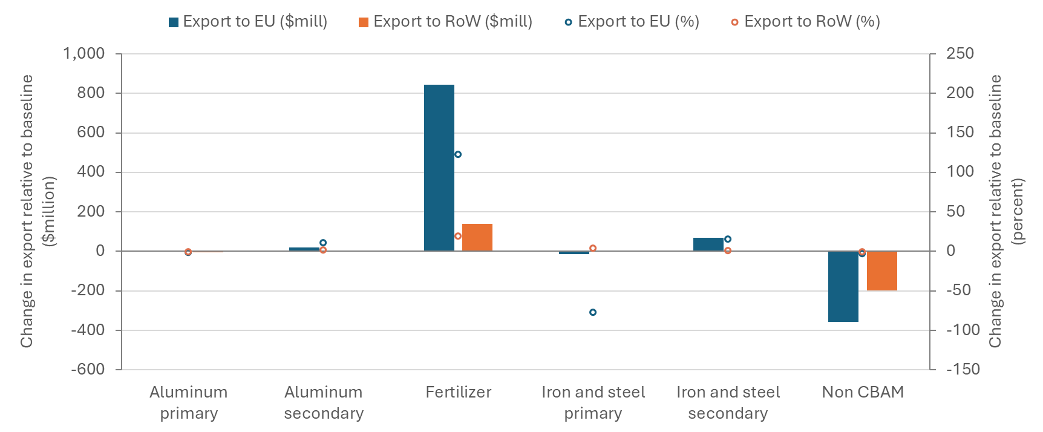
Source: Alsharkas et al. (2026)
Compared to regional peers, the CBAM scenario has relatively small effects on Egypt’s terms of trade. Morocco stands out with the largest improvement terms of trade, due to its lower carbon intensity among its main CBAM exports and its status as a fossil-fuel importer, benefitting from downward pressure on global fuel prices. All of the major fossil-fuel exporters suffer decreases in their terms of trade, with Algeria experiencing the largest. Egypt, by contrast, has a fairly balanced net export position in oil and gas.
Figure 7: CBAM policy-induced changes in terms of trade across selected MENA countries
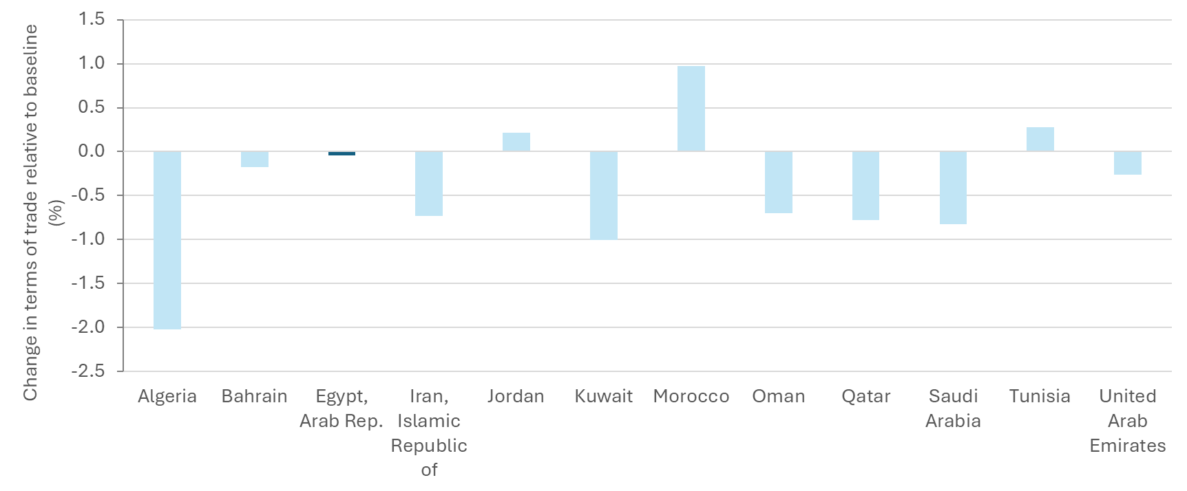
Source: Alsharkas et al. (2026)
In terms of GDP, the full implementation of the CBAM policy—along with its worldwide impacts—leads to a roughly 0.2% decrease in Egyptian GDP. This effect is modest but relatively large compared to peers, likely due to Egypt’s close trade relations with the EU and the loss in demand for imports more generally.
Figure 8: GDP impacts across MENA region of CBAM implementation
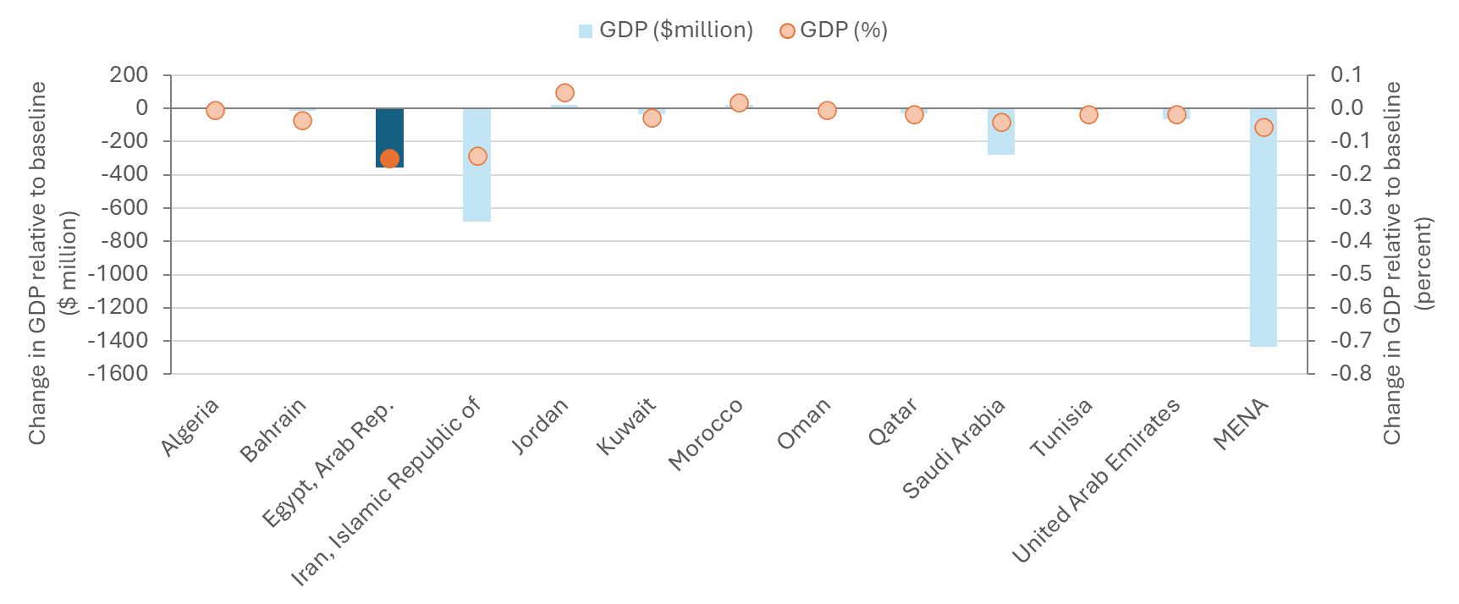
Source: Alsharkas et al. (2026)
However, in welfare terms, Egypt is less affected than its fossil-fuel exporting neighbors, who lose buying power for consumption due to the erosion of terms of trade.
Figure 9: Welfare effects of CBAM implementation
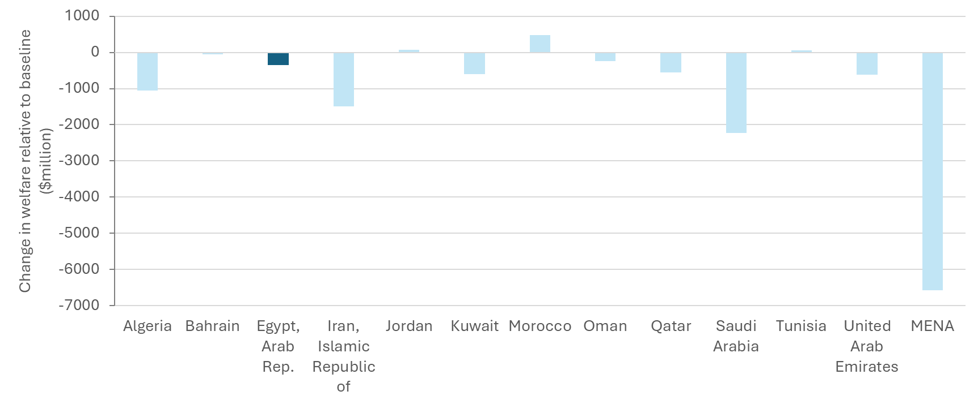
Source: Alsharkas et al. (2026)
These simulations assume the absence of any direct carbon price instrument in Egypt. In this case, the EU CBAM could result in significant carbon revenue transfers to the EU by importers of Egyptian exports. In the absence of a carbon tax or an ETS, estimates based on historical export data, default emission factors, and an EU ETS price of USD 100 per metric ton of CO₂e suggest that EU importers of Egyptian exports could incur USD 400 million annually in carbon payments to the EU once the CBAM is fully phased in (and twice that if the additional 180 products are included). This amount represents around 0.28% of GDP or roughly 1.5% of Egypt's total annual tax revenues—a significant fiscal opportunity.

Risks and opportunities from CBAM for Egypt
The main risks from CBAM relate to the required monitoring, reporting, and verification (MRV). Without robust MRV systems and accredited verifiers available for Egyptian producers, importers of Egyptian CBAM goods will need to rely on the assigned default values from third countries, which are likely higher than the actual emissions intensity of the local industry (for domestic steel in particular). Notably, the defaults for all products will have a 30% markup within three years, with the exception of fertilizers, which will have a lower, 1%, markup. To avoid extra charges and remain competitive, Egyptian exporters will need to be able report their actual emissions to the EU importers.
EU Member States’ National Accreditation Bodies are now in the process of accrediting verifiers for CBAM. National Accreditation Bodies in some EU countries have already started accepting applications not only from verifiers established in the EU but also from those established outside the EU. At the same time, the Egyptian Ministry of Foreign Trade is taking steps to get ready, introducing a platform for emissions data management. The ultimate costs of verifying shipments are still uncertain, but they could fall more heavily on smaller exporters. If small exporters are working with small importers in the EU, they might fall under the latter’s 50-tonne threshold for exemption from the CBAM scope. The level and distribution of these costs in terms of ad-valorem equivalents on CBAM goods exports are important unresolved questions for assessing overall exposure, as well as the absence of firm-level information regarding Egyptian exporters and their emissions profiles.
At the same time, Egypt could be well positioned to be able to benefit from the CBAM, given its competitive emissions profile in these industries, its proximity to the EU to take advantage, and the demand that EU climate policies will create for its emerging low-carbon industries. The latest data indicate that Egyptian producers have similar emission profiles to their EU and global peers and in some cases outperform them. The better performers within Egypt will then gain a competitive advantage serving EU markets—provided they are able to document their emissions according to the required CBAM methodology. EU consumers will be paying a premium for low-carbon goods that carry fewer embedded emissions costs, and Egypt is an established trade partner. The EU’s climate policy ambition, reinforced by the CBAM, will expand markets for green hydrogen and renewable electricity, in which Egypt is already negotiating strategic investments and partnerships that will build jobs in a clean-energy economy.
Egypt can also take advantage of the moment to reinforce its own clean industrial ambitions with synergistic CBAM response policies. Egypt is currently building a national MRV system that could integrate industrial sector emissions for transparent reporting and to meet CBAM obligations. Building MRV capacity for exporters lays much of the groundwork for the emissions monitoring which may be needed to design and enforce future domestic emissions regulations. Implementing effective emission reduction policies will further improve the low-carbon competitiveness of Egyptian industries, reduce CBAM obligations, and provide local benefits in terms of improved air quality and health. To the extent that these policies involve carbon pricing at the installation level, the benefits include both the cost-effectiveness of incentive-based measures and also the reduction of CBAM obligations, recognizing the carbon payments already made. For Egyptian exporters, the carbon costs are the same whether the EU or Egypt collects them. Using carbon pricing keeps the carbon revenues at home in Egypt to fund domestic priorities. In these ways, the CBAM lowers the costs of implementing the domestic policy agenda.

Policy options in view of CBAM and national objectives
This section provides foundational information toward structuring strategies to enhance Egypt’s competitiveness in CBAM-related trade by considering policy options for reducing embedded emissions, with an emphasis on direct carbon pricing mechanism that could help Egypt retain carbon revenues that would otherwise be transferred to the EU. After highlighting key provisions in the draft CBAM rules for the likely treatment of carbon pricing policy features, different approaches to pricing carbon are illustrated through examples from global experience. Then modelling tools are applied to compare the implications for Egypt of different policy strategies.

CBAM provisions regarding carbon pricing in third countries
Recognizing carbon pricing effectively paid in third countries is a component of good practice for several reasons: It avoids double taxation, ensures compliance with international trade law by avoiding discrimination, and encourages wider adoption of carbon pricing.
The CBAM framework allows importers to claim a reduction in their CBAM liability if and to the extent that they can demonstrate embedded emissions were subject to a qualifying carbon price in the country of origin. The importer would have to demonstrate that the carbon price was levied, paid, and that there was no offsetting exemption, rebate or other compensation (including free allocation).
As mentioned above in section 2, the EU Commission recently released a draft implementing regulation to set rules regarding the more detailed calculation of an effectively paid carbon price, allowing for a reduction in the number of CBAM certificates to surrender. The draft act is still under discussion within the EU; however, a few important provisions from the draft can be highlighted as relevant when considering the different policy options that follow.
First, for the purpose of this liability reduction, the CBAM Regulation sets out that a carbon price only refers to the monetary amount paid under an ETS or a “carbon tax, levy or fee”. It is not intended to include implicit carbon costs that may be associated with other regulations that do not price residual emissions. However, it does specifically provide for carbon prices levied in the form of fuel consumption taxes, when the tax basis is the carbon content.
Second, the draft underscores that only carbon pricing mechanisms that are binding in nature and imposed on all operators active in the relevant sectors will be recognized. I.e., carbon prices must be grounded in a domestic compliance mechanism for the industry as a whole, and policies narrowly targeting exports will not be recognized.
Third, most rebates, exemptions, free allocation, or other forms of compensation to covered entities will be deemed to reduce the effective carbon price. These include many commonly used forms of free allocation in emissions trading systems, including baseline and credit systems, intensity standards, benchmark allocations, etc.
Fourth, the draft explicitly carves a particular exception for subsidies with the objective of reducing the emissions of the beneficiary installation, as opposed to compensating it for residual emissions. To qualify, the opportunity should be open to all, not based on the installation’s carbon payments, and transparently granted through an application process. Further clarity is needed as to how domestically applicable subsidy schemes not directly linked to the carbon price paid will be accounted for.
Fifth, the draft rules have provisions relevant for the use of carbon credits to reduce CBAM obligations. Purchases of carbon credits used as part of a domestic compliance system would be recognized based on their actual costs Where the domestic compliance mechanism allows for the use of international offset credits, they should meet the standards set under the Paris agreement and would be limited to 10% of the reported emissions. The draft rules do not provide for carbon credit purchases outside of a domestic compliance mechanism—such as voluntary purchases—to reduce CBAM obligations.
Although different stakeholders have floated the idea of allowing exporters from developing countries (or their importing partners) to make some form of carbon payments on exports in lieu of purchasing CBAM certificates, none of these are currently sanctioned by the EU. Still, they are worth discussing.
For example, the Egyptian government has proposed an option of voluntary contributions to a decarbonization fund as a way to keep CBAM payments at home but in a capacity dedicated to furthering emission reductions among the industries. If credibly and transparently implemented, Egyptian exports to the EU would still bear the same carbon costs, and the revenues would stay at home. Another proposal advanced in certain circles (e.g., Sandler 2025), with a similar rationale, would be to allow payments made for Article 6 credits to be recognized in lieu of CBAM certificate costs. The CBAM revenues would then implicitly be earmarked to fund emission reductions in developing countries. Both of these options face acceptability problems.
The EU has made clear that carbon pricing effectively paid must derive from a compliance system applied to all producers within a sector; otherwise, the overall carbon costs borne by producers are asymmetric. Indeed, export-only options do not count as eligible for deduction under CBAM. Nor do EU producers have the opportunity to meet their obligations with payments for carbon credits. Furthermore, it can be difficult to assess the integrity of a voluntary contribution system and the credibility of the reductions made. WTO rules also look skeptically at special treatment of exports, although in these cases a cost rather than a subsidy are involved.
A final option that has been proposed would be to recognize the value of carbon credit purchases for exports, but only if tied to a domestic compliance carbon pricing instrument (Fischer and Mehling 2026). For example, if an industrial carbon pricing system relies on output-based rebating, the rebate would normally reduce the effective carbon price, but allowing carbon credit purchases to “top up” the carbon costs on exports to the EU—at least up to the domestic carbon price—could be a way to recognizing carbon pricing progress while respecting other countries’ desires to manage their own competitiveness issues vis-à-vis non-EU trade partners. It remains to be seen whether the Commission will provide for such options in the final rules.

A range of policy options
Different policy actions could be brought to bear to encourage industrial emission reductions, reduce CBAM obligations associated with exports, and also achieve broader reductions and economic benefits. These range from narrow regulatory options and targeted investment strategies to reduce industrial emissions to broad-based interventions that encourage an array of emitters to economize on their use of polluting fossil fuels and innovate alternatives. The associated benefits of such policies can go far beyond the savings in terms of CBAM obligations to include alignment with NDCs, improved productivity, better air quality, reduced mortality, and higher fiscal revenues to fund national priorities.
Carbon pricing carries particular advantages over other mitigation interventions in reducing exposure to CBAM as it reduces both the base and rate of payments. Numerous interventions can reduce CBAM obligations by reducing the emissions intensity of goods. Sectoral regulations, public investments, green bonds and others can all play important roles in reducing emissions from CBAM goods and thereby the “tax base” on which CBAM payments are based. What they cannot reduce, however, is the CBAM price applied to the remaining emissions. Carbon pricing is the only mitigation instrument that both reduces the tax base, by reducing the embedded emissions of a CBAM good, and reduces the tax rate, by deducting from the EU ETS price that is applied to the remaining embedded emissions.
Egypt can retain CBAM related revenues domestically by establishing a qualifying carbon pricing mechanism, ensuring that payments remain within the national economy rather than being transferred to the EU. The financial payments from EU importers of Egyptian exports would be reduced by deducting domestic carbon price payments to the Egyptian government through a carbon tax, levy, or ETS applied in proportion to the GHG emissions generated in the production of the good. In this way, Egyptian exporters would not bear additional costs from the imposition of a domestic carbon price, and carbon payments by other domestic producers would expand the domestic environmental benefits and revenues. These benefits can be weighed against the costs to design an appropriate level of stringency and transition period for the Egyptian context.
Global experience provides many examples of carbon pricing approaches designed to meet domestic objectives. They vary not only by instrument choice but also by the points of intervention, degree of emissions coverage, price developments, and free allocation strategies for industries. We distinguish approaches by whether they target “downstream” emissions at the point-source level of industrial facilities, intervene “upstream” to charge for the carbon content of fossil fuels consumed by point- and non-point-sources alike, or aim to cover greenhouse gas emissions more comprehensively in the economy.

Downstream carbon price on heavy industry
Many carbon pricing systems have been focused on the direct emissions of point sources, covering both combustion and process emissions from major facilities in such emissions-intensive sectors as power generation and heavy manufacturing like steel and cement. These facilities typically already operate under a range of environmental regulations, with performance requirements for operating permits and maximum allowable emissions for air and water pollutants. The innovation with market-based regulations is to determine a sector-wide emissions price or trading system, incentivizing facilities to abate emissions as long as the cost of doing so is less than the prevailing emissions tax or allowance price. As a result, facilities with lower costs of abatement can overcomply with the standard and sell allowances or avoid tax payments, while facilities with costlier abatement opportunities can purchase allowances or pay emissions taxes to meet the remainder of the compliance goal, resulting in lower overall costs of meeting the target.
Downstream carbon pricing systems can be distinguished in practice according to how the revenues are allocated between the government and the participants. These decisions about the allocation of emissions values have important implications both for the economic implications and for the potential reduction in CBAM allocations.
An example of a downstream system with emission rents accruing to the government is Chile's carbon tax (or “impuesto verde”), which was designed with multiple goals in mind: raising revenues to fund education and health reforms, addressing severe urban air quality problems, and reducing GHG emissions in line with Chile's climate NDCs. The tax applies to stationary sources with annual emissions of 25,000 tCO₂ or more., covering about 33% of Chile's total GHG emissions, primarily in the power and industrial sectors. Since the revenues are retained by the government, the full carbon payments by producers of CBAM products should be applied toward CBAM obligations, although with a tax rate of US$5 per tCO₂e, the creditable amount remains small relative to the price of obligations. Still, Chile has raised US$165–168 million per year in the first years of implementation, and it aims to raise the carbon price in the next decade.
Most downstream pricing systems covering heavy industries have adopted emissions trading systems, typically with generous free allocation to covered facilities to start. These industries tend to have large firms that are economically and politically important stakeholders and products that are relatively highly exposed to trade, leading to the use of mechanisms to limit the impact of the carbon pricing system on industrial competitiveness.
The most prominent example among emerging economies is China's national ETS, which began with large facilities in the power sector and expanded in 2025 to include the cement, steel, and aluminum sectors. Facilities with annual emissions of more than 26,000 tCO2e are covered, currently representing roughly half of China's national emissions. The system embeds free, output-based allocation by using a collection of carbon-intensity benchmarks tied to actual production levels, meaning the cap adjusts with output. The policy in that way partly mirrors the intensity-based targets in China’s NDC. However, no revenues are collected, since allowances are allocated for free. The free allocation limits the costs that regulated firms bear, avoiding possible dislocations but also limiting the effectiveness of the policy at reducing emissions, since lower-carbon sources have lower rates of free allocation and thus do not become more competitive relative to higher-emitting sources with more generous intensity standards.
The benchmarking allocation system falls under the types of rebates that the draft CBAM rules deem would offset carbon pricing effectively paid, meaning little or no net carbon price would be recognized for reducing CBAM obligations. In part for these reasons and to allow for increasing ambition in emissions reductions, a roadmap toward an absolute emissions cap (replacing the current intensity-based approach) is expected by 2027 or shortly thereafter, further facilitating more auctioning and net effective carbon pricing on embodied emissions.
Some jurisdictions have experimented with using revenues from a downstream pricing system to support industrial abatement. For example, the Canadian province of Alberta has a Technology Innovation and Emissions Reduction (TIER) system, which takes an intensity-based emissions trading approach for industrial emitters and offers an alternative compliance option of paying into the TIER fund at a fixed price (currently CAD 95). The TIER fund, administered by Emissions Reduction Alberta, uses funding competitions and grants to support a variety of initiatives to reduce emissions, clean technology development, climate change adaptation, and a carbon capture incentive program. From a CBAM perspective, under the Alberta-style example, although the free allocation through the baseline-and-credit system would reduce the carbon price effectively paid, carbon payments made into the Fund would be deductible, and investment support to the low-carbon technology projects would not reduce that effective carbon price.

An upstream carbon levy on the carbon content in fuels
An approach that covers a large share of GHG emissions without requiring point-source regulatory interventions is to focus “upstream” on the carbon content of fossil fuels, leveraging the fuel excise tax systems that many countries have in place. Upstream carbon fuel excise taxes are common in several jurisdictions, including many across the Americas. Countries like Colombia, Argentina, Mexico and Uruguay began with carbon levies on certain fuel types or sectors and have gradually expanded the scope of their upstream carbon pricing systems.
The most comprehensive upstream carbon pricing system was British Columbia’s carbon tax, which was applied uniformly to virtually all fossil fuels purchased or used in the province—gasoline, diesel, natural gas, propane, coal, fuel oil, and peat and tires combusted for energy—covering approximately 70% of the province's total GHG emissions. It was collected upstream at the fuel distributor level, leveraging the same administrative infrastructure as existing motor fuel taxes, which allowed it to be implemented rapidly and at low administrative cost. The revenues were dedicated to reducing other taxes paid by British Columbians, without sector-specific exemptions.
As the EU recognizes carbon fuel excise taxes as a carbon price possible to deduct from the CBAM financial obligation, jurisdictions are looking into recalculating existing indirect fuel excise taxes into direct carbon fuel taxes, ensuring that fuels used in the production of CBAM goods are within the scope of the carbon fuel excise tax. Examples in the vicinity of Egypt include Albania, which from 1 July 2026 applies such a tax on coal, calculated on the basis of standard carbon content of the fuel, at a rate trajectory gradually narrowing the gap between Albania’s effective carbon price on coal and the projected 2030 EU ETS price at 64 EUR per tonne of CO₂. Another example is Israel, which during 2025-2030 gradually introduces a carbon fuel excise tax on natural gas, LPG, fuel oil and coal complemented by a program to fund projects to help industry become more energy efficient and more competitive and reduce GHG emissions. For gasoline and diesel, Israel is introducing the carbon tax as a component of existing excise taxes. Armenia and Uzbekistan are considering similar reforms.
A limitation of upstream carbon pricing is that emissions from non-combustion use in industrial processes—which can be large in CBAM sectors—can remain uncovered. In cement production in particular, process emissions from calcination of limestone represent the bulk of emissions and cannot be captured from upstream pricing of fuel inputs. For other CBAM sectors, like fertilizers or metals, a significant share of the industrial process emissions stem from the use of fossil fuels for chemical transformation or reduction. The EU Commission’s draft implementing regulation on carbon price paid recognizes the full price paid on fuels consumed by in the relevant CBAM industrial process, independently of if the standard emission factors at combustion has been used to calculate a fuel-based carbon tax. A technical hands-on description of how to calculate an upstream carbon fuel excise levy is found in an annex to this paper as supplementary information. A specific focus is given to design simplicity in using already existing administrative tax collection systems to recalculate pre-existing indirect fuel excises.

Comprehensive carbon pricing system
A comprehensive carbon pricing system aims to cover as many of the direct (scope 1) GHG emissions in an economy as are practical—that is, from both fossil fuel combustion and industrial processes. Harder-to-measure emissions from LULUCF, agriculture, and other sources like fugitive emissions such as those from mining may require complementary interventions. As a result, for the same carbon price, comprehensive systems have a greater potential to reduce national emissions and raise fiscal revenues.
Many jurisdictions blend downstream and upstream carbon pricing to arrive at comprehensive coverage. For example, many EU member states use upstream carbon taxes to price carbon for sectors outside the downstream EU ETS. California has been able to cover approximately 85% of the state's GHG emissions by applying its cap-and-trade system to around 450 businesses, including point-source emissions from power plants and industrial facilities and covering fuel-related emissions upstream with fuel distributors.
Some systems aim to capture as many emissions as possible from broad point-source regulation. South Africa’s carbon tax is an example of this approach. It applies to stationary and some non-stationary sources with a thermal design capacity of 10 MW or more, spanning industry, buildings, and transport (excluding public transport). It covers approximately 80–90% of the country's total GHG emissions. The tax was chosen over an emissions trading system partly because the concentrated, oligopolistic structure of South Africa's energy sector (dominated by Eskom) would have produced insufficient market liquidity for a functioning ETS.
For CBAM sectors, the deductibility of a comprehensive carbon price depends on the coverage and treatment of the relevant facilities. For example, the generous allowance structure of the South African carbon tax—including a basic 60% tax-free allowance for all activities and up to an additional 35% in rebates for certain companies—substantially reduces a company's effective tax liability, which the draft CBAM rules would take into account. Future plans are for the generous basic allowances to be gradually phased out, which would enhance the effective carbon price. California's cap-and-trade program provides free allowance allocations to industrial emitters primarily to address the risk of carbon leakage; the resulting adjusted product-based benchmarks would also be taken into account under CBAM rules.

Simulated policy outcomes for Egypt
This section presents the results from simulating six stylized policy options for Egypt using the Climate Policy Assessment Tool (CPAT). The modeled scenarios are designed to be directly comparable. Scenarios have in common the 2030 carbon price fixed at $20 per ton of CO₂ so that differences in outcomes reflect policy design rather than price level. What varies across the bundles is the point at which the price is applied, the share of national emissions it reaches, and the manner in which resulting revenues are recycled. The scenarios fall into three families, spanning a coverage range from 72 percent to 20 percent of national greenhouse gas emissions.

An overview of the Climate Policy Assessment Tool
The Climate Policy Assessment Tool (CPAT) is a spreadsheet-based model developed jointly by the IMF and World Bank for government use, covering around 190 countries. It provides a rapid assessment of climate policy reforms—carbon taxes, fossil fuel subsidy reform, feebates, and revenue-use options—across energy and emissions, macro and fiscal outcomes, distributional effects, and co-benefits such as air pollution, health, and transport. It is a diagnostic and scenario-analysis tool: a quick first look that complements rather than replaces more detailed macroeconomic or techno-economic models.
CPAT lets analysts design, compare, and stress-test multiple policies quickly, across a wider set of countries and impact metrics than bespoke modeling usually allows. Its outputs feed directly into operational products—Country Climate Development Reports, Public Finance Reviews, technical assistance, and ad hoc client requests—with completed studies in 72-plus countries and distributional data in 74-plus. Beyond emissions, it surfaces the fiscal case for carbon pricing: a more efficient way to raise needed revenues through a less distortive tax system, alongside resources that can be recycled to protect poorer households from regressive effects. github
CPAT is built from interacting modules running off a central dashboard where the user sets policies and assumptions. A core mitigation module estimates prices, energy use, emissions, revenue, and GDP, with dedicated air pollution, transport, and distribution modules layered on top. Methodologically, it rests on price and GDP elasticities, a power-sector model, and GDP multipliers. Because the data and formulas are accessible within the tool and documented at length, every assumption behind a result stays visible—the discipline that lets users interpret the numbers responsibly

Modeled policy scenarios
The first scenario (1A) represents the most comprehensive option, combining an upstream carbon levy on all fossil fuel consumption with a downstream charge on process emissions in CBAM sectors. Modeled in CPAT as energy-related CO₂ across all sectors plus CBAM process emissions, it achieves the broadest coverage in the matrix at 72 percent of national greenhouse gases. The price is applied at a flat $20/tCO2e levy from 2028, supplemented by a separate $20/tCO2e fee on CBAM-sector process emissions, with revenues recycled to (non-green) public investment.
The second family (2A and 2B) model upstream carbon pricing alone, while isolating the effect of revenue recycling by holding the policy design otherwise constant. Both apply an upstream carbon levy on all fossil fuel consumption, modeled as a flat $20/tCO2e price from 2028, levied on energy CO₂ across all sectors, which covers 65 percent of national greenhouse gases. The two variants differ only in the use of proceeds: 2A directs revenues to (non-green) public investment, while 2B returns them to households on a per-capita basis, allowing a clean comparison of the distributional and macroeconomic consequences of the recycling choice.
The third family (3A, 3B, and 3C) examines downstream pricing on heavy industry, the narrowest option, covering roughly 20 percent of national greenhouse gases. These scenarios are modeled as applying to energy CO₂ for industry plus all process emissions in CBAM sectors, with the price phased in from $5 to $50 by 2034 (reaching $20 in 2030) and applied to industry only. The three variants are distinguished by how value is returned: 3A recycles revenues to households (like 2B, but with fewer revenues to return); 3B pairs the price with free allocation for CBAM producers on an intensity benchmark per unit of output, returning value to firms through output support; and 3C provides a rebate for industrial abatement, channeling value toward additional emissions reductions at the firm level.
Taken together, the matrix is structured along three axes that allow each policy lever to be assessed independently: the point of imposition (upstream versus downstream), the breadth of emissions coverage (declining from 72 to 65 to 20 percent), and the revenue recycling option (public investment, households, or firms). Because the headline carbon price is held constant across all six bundles in the reporting year of 2030, differences in modeled outcomes can be attributed to these design choices rather than to the stringency of the price itself.

Code | Policy bundle | Implementation in CPAT / Adjustment to CPAT Scenario | Scenario assumptions ($20 in 2030 for all) | Carbon price in 2030 | Revenue Recycling Option
1A | Comprehensive carbon levy: upstream carbon price on all fossil fuel consumption + downstream emissions in CBAM sectors only + recycling to (non-green) public investment | Energy CO2 in all sectors + CBAM process emissions ONLY (72% national GHGs covered) | Overall; $20 flat from 2028 + separate $20 fee in process emissions of CBAM sectors | $20 | Public investment
2A | Upstream carbon levy on all fossil fuel consumption + recycling to (non-green) public investment | Energy CO2 in all sectors  (65% national GHGs covered) | $20 flat from 2028 | $20 | Public investment
2B | Upstream carbon levy on all fossil fuel consumption + recycling to households | Energy CO2 in all sectors  (65% national GHGs covered) | $20 flat from 2028 | $20 | Households
3A | Downstream carbon price on heavy industry + recycling to households | Energy CO2 only for ALL industry plus all process emissions in CBAM sectors  (20% national GHGs covered) | Phased-in price from $5 to $50 in 2034 ($20 in 2030). Industry only | $20 | Households
3B | Downstream carbon price on heavy industry + free allocation for CBAM producers  (intensity benchmark per unit of output) |  |  | $20 | Firms (output)
3C | Downstream carbon price on heavy industry + rebate for industrial abatement |  |  | $20 | Firms (abatement)

Revenues
Importantly, carbon emissions represent a significantly underutilized tax base that could boost public revenues. Unlike traditional tax bases, such as labor or corporate income, taxing pollution can enhance economic efficiency by correcting market failures, internalizing negative externalities associated with air pollution, rather than discouraging productive activities. By convention, revenues recycled macroeconomically —for example to public investment or to households—are counted as carbon revenues, whereas value returned to firms through free allocation or industrial rebates is not, since it offsets the price at source rather than passing through the budget. On this basis, the comprehensive carbon levy (1A) raises the most, at $5.8 billion—roughly equivalent to 10% of current government revenues. The two upstream levies (2A and 2B) follow closely, each generating $5.2 billion whether proceeds are recycled to public investment or to households. The downstream price recycled to households (3A) raises considerably less, at $1.1 billion, reflecting its narrower base. The two remaining downstream designs raise no carbon revenue: free allocation for CBAM producers (3B) and the rebate for industrial abatement (3C) both channel value back to firms, which by this convention falls outside measured revenues.

Code | Policy bundle | Carbon revenues raised ($bn)
 | Policy Bundle Options - Carbon Pricing (modelled)
1A | Comprehensive carbon levy: upstream carbon price on all fossil fuel consumption + downstream emissions in CBAM sectors only + recycling to (non-green) public investment | 5.8
2A | Upstream carbon levy on all fossil fuel consumption + recycling to (non-green) public investment | 5.2
2B | Upstream carbon levy on all fossil fuel consumption + recycling to households | 5.2
3A | Downstream carbon price on heavy industry  + recycling to households | 1.1
3B | Downstream carbon price on heavy industry + free allocation for CBAM producers (intensity benchmark per unit of output) | 0.0
3C | Downstream carbon price on heavy industry + rebate for industrial abatement | 0.0

Emissions reductions and reductions in CBAM obligations
Estimated emissions reductions range from 41.6 to 13.6 MtCO₂ across the bundles, equivalent to roughly 5 to 17 percent of Egypt's annual CO₂ emissions of about 249 MtCO₂. The comprehensive carbon levy (1A) achieves the most emissions reduction, at 41.6 MtCO₂ (about 17 percent of national emissions), reflecting its wide coverage of both energy and CBAM-sector process emissions. The two upstream levies follow closely: the household-recycling variant (2B) reduces emissions by 41.0 MtCO₂ (about 16 percent) and the public-investment variant (2A) by 38.9 MtCO₂ (about 16 percent), the modest difference between them arising from how each recycling choice feeds back into energy demand. Reductions fall substantially under the downstream-only options, which reach a narrower industrial base: the industrial carbon price with rebate for industrial abatement (3C) delivers 24.5 MtCO₂ (about 10 percent), the household-recycling design (3A) 21.5 MtCO₂ (about 9 percent), and the free-allocation design (3B) the least at 13.6 MtCO₂ (about 5 percent), as free allocation on an output-intensity benchmark weakens the incentive to abate.
The bundles differ considerably in how effectively they reduce Egypt's exposure to the EU CBAM, with reductions in CBAM obligations ranging from 7.6 to 30.4 percent depending on how comprehensively the price reaches CBAM sectors and how strongly it incentivizes abatement. The comprehensive carbon levy and downstream pricing designs all achieve full coverage of CBAM sectors; however, the choice of rebating influence the change in emissions and CBAM obligations. The comprehensive carbon levy (1A) and the downstream price recycled to households (3A) produce identical carbon intensity reductions of 7.6 percent of baseline, and each cut CBAM obligations by 26.1 percent. The downstream price paired with free allocation for CBAM producers (3B) achieves the same intensity reduction, and that is the only factor driving the 7.6 reduction in CBAM obligations, since free allocation on an output-based intensity benchmark fully offsets the carbon price effectively paid on embodied emissions. The two upstream carbon levies (2A and 2B) cover only 44 percent of CBAM sector emissions and therefore deliver a smaller intensity reduction of 5.5 percent and a 13.9 percent cut in obligations, with no difference between the two recycling choices. The strongest performer by these metrics is the downstream carbon price combined with a rebate for industrial abatement (3C), which—at full coverage—achieves the largest intensity reduction of 13.1 percent of baseline and the greatest reduction in CBAM obligations, at 30.4 percent, because the rebate incentivizes additional emissions reductions per unit of output without diluting the pass-through of the emissions price signal.
Code | Policy bundle | Estimated total emissions reductions (MtCO2) | CBAM coverage (% of CBAM sectors) | Emis. intensity reduction, CBAM sectors (% of baseline) | CBAM obligations reduced | Industrial Output Change
 | Policy Bundle Options - Carbon Pricing (modelled)
1A | Comprehensive carbon levy: upstream carbon price on all fossil fuel consumption + downstream emissions in CBAM sectors only + recycling to (non-green) public investment | -41.6 | 100% | -7.6% | -26.1% | -4%
2A | Upstream carbon levy on all fossil fuel consumption + recycling to (non-green) public investment | -38.9 | 44% | -5.5% | -13.9% | -4%
2B | Upstream carbon levy on all fossil fuel consumption + recycling to households | -41.0 | 44% | -5.5% | -13.9% | -4%
3A | Downstream carbon price on heavy industry  + recycling to households | -21.5 | 100% | -7.6% | -26.1% | -11%
3B | Downstream carbon price on heavy industry + free allocation for CBAM producers  (intensity benchmark per unit of output) | -13.6 | 100% | -7.6% | -7.6% | -4%
3C | Downstream carbon price on heavy industry + rebate for industrial abatement | -24.5 | 100% | -13.1% | -30.4% | -9%

Co-benefits
The benefits of carbon pricing extend beyond environmental goals: implemented properly, it can yield significant societal benefits, including job creation, improved health outcomes, and greater equity, while fostering a simpler, more growth-friendly system that extends to the informal sector. In other words, pricing carbon could be in Egypt’s own interest.
Broad-based carbon pricing instruments that raise revenues can have lower costs to economic growth than conventional taxes. Covering large informal sectors and using the revenues to substitute formal-sector taxes creates opportunities to boost output. A broad tax base allows carbon taxation to raise revenues more efficiently, with less negative impact on output compared to conventional taxes. Employment outcomes are also likely better with upstream carbon taxes than with some conventional taxes, especially those on labor ― for two reasons. Policy-driven decarbonization can shift the economy toward more labor-intensive sectors and increase labor intensity within sectors by transforming production methods. By reserving some of the revenues raised for redistribution to low-income households or to public services that benefit them, a carbon tax shift can also be pro-poor.
Furthermore, development co-benefits are particularly pronounced in Egypt. By discouraging pollution-intensive activities, carbon taxation can improve air quality, enhance public health, and reduce social costs that come with road use, including congestion, accidents, and road damages. These effects are so large that many researchers have found them to exceed the economic cost of mitigation. All this means that there are national economic interests for taxing carbon, independent from its contribution to climate objectives and reduced CBAM liabilities.

Code | Policy bundle | Air pollution deaths avoided
 | Policy Bundle Options - Carbon Pricing (modelled)
1A | Comprehensive carbon levy: upstream carbon price on all fossil fuel consumption + downstream emissions in CBAM sectors only + recycling to (non-green) public investment | 1656
2A | Upstream carbon levy on all fossil fuel consumption + recycling to (non-green) public investment | 1564
2B | Upstream carbon levy on all fossil fuel consumption + recycling to households | 1631
3A | Downstream carbon price on heavy industry  + recycling to households | 546
3B | Downstream carbon price on heavy industry + free allocation for CBAM producers  (intensity benchmark per unit of output) | 345
3C | Downstream carbon price on heavy industry +  rebate for industrial abatement | 621

CPAT modeling results focus on the mortality benefits from reduced air pollution. Across the scenarios, the carbon pricing bundles deliver substantial air pollution co-benefits, avoiding between 345 and 1,656 premature deaths annually, broadly in line with the breadth of fuel combustion each option covers. The comprehensive carbon levy (1A) yields the largest health gain, with 1,656 deaths avoided, reflecting its wide coverage of fossil fuel combustion across the economy. The two upstream levies follow closely: the household-recycling variant (2B) avoids 1,631 deaths and the public-investment variant (2A) 1,564, the difference tracking their slightly different effects on energy demand. The downstream options on heavy industry deliver markedly smaller health benefits, since they leave most combustion sources—notably in transport and buildings—unpriced: the rebate for industrial abatement (3C) avoids 621 deaths, the household-recycling design (3A) 546, and the free-allocation design (3B) the fewest at 345. These co-benefits accrue domestically and in the near term, independent of global mitigation outcomes, and typically constitute a significant share of the overall welfare case for carbon pricing.

Summary of tradeoffs and implications for Egypt
Taken together, the six bundles illustrate a central tension in carbon policy design: the choices that maximize domestic fiscal and health returns are not the same as those that most reduce CBAM exposure, and no single option dominates on every dimension. The comprehensive carbon levy (1A) emerges as the most balanced performer, combining the broadest emissions coverage with the largest emissions reductions (41.6 MtCO₂), the highest carbon revenues ($5.8 billion), and the greatest air pollution co-benefits (1,656 deaths avoided), while also delivering a substantial cut in CBAM obligations (26.1 percent). The upstream levies (2A and 2B) achieve nearly comparable mitigation, revenue, and health outcomes, but their narrower reach into CBAM sectors leaves more of Egypt's CBAM exposure unaddressed.
The principal trade-offs cluster around three levers.
The first is the point of imposition: broad-based upstream and comprehensive pricing maximizes economy-wide gains—emissions, revenue, and health—because it reaches transport, buildings, and power, whereas downstream industrial pricing concentrates effort on a narrow base and forgoes most of those co-benefits.
The second is revenue recycling: directing proceeds to public investment or households preserves measured carbon revenues, while returning value to firms through free allocation (3B) or rebates (3C) sacrifices fiscal yield. Additional modeling including trade and industrial structure details would be helpful to understand the tradeoffs in terms of competitiveness impacts on domestic and non-EU foreign markets.
The third is CBAM optimization, where the rebate-for-industrial-abatement design (3C) stands apart—achieving the deepest cut in CBAM obligations (30.4 percent) precisely because it rewards abatement without blunting the marginal price signal, unlike free allocation (3B), which protects competitiveness but undermines both revenue and CBAM relief.
The implication for Egypt is that the "best" bundle depends on which objective is weighted most heavily. If the priority is raising revenue and maximizing domestic welfare, comprehensive or upstream pricing is clearly preferable. If the overriding concern is shielding exporters from CBAM costs while maintaining abatement incentives, the rebate-based industrial design is most effective, albeit at the cost of forgone revenue and health benefits. Free allocation, by contrast, performs weakly across nearly all metrics and offers competitiveness protection only by suppressing the very price signal that drives mitigation. A sequenced strategy—beginning with a broad-based price and complementing it with well-designed, abatement-linked support for CBAM-exposed industry—would capture most of the economy-wide benefits while managing trade exposure. Pairing any of these options with fossil fuel subsidy reform would further strengthen both the price signal and the fiscal return.

Importance of complementary options for decarbonizing industry
As the EU CBAM enters its operational phase and global decarbonization pressures intensify, Egypt will need to take a proactive and sustained approach to developing a portfolio of policies for industrial decarbonization. Beyond short-term compliance, a longer-term structural response is needed, aimed at maintaining export competitiveness, securing market access, and positioning Egypt within emerging low-carbon value chains. Key priorities include establishing robust monitoring, reporting, and verification (MRV) systems at the facility and product level, providing clear and predictable policy and regulatory signals for low-carbon production (including energy pricing, renewable energy access, and industrial standards), and advancing carbon pricing or equivalent instruments that are compatible with CBAM requirements. These policy measures will be critical not only to reduce embedded emissions and associated CBAM liabilities, but also to enable Egyptian producers to demonstrate their carbon performance and compete effectively in EU and other low-carbon markets.
At the same time, a comprehensive response will require sustained efforts to facilitate and scale investment in industrial decarbonization, including through targeted green industrial policies, investment promotion, and financial sector reforms. This includes supporting sector-specific transition pathways (e.g., steel, fertilizers, cement, aluminum), enabling infrastructure investments in renewable energy, hydrogen, and industrial clusters, and building the capacity of firms—particularly SMEs—to adopt low-carbon technologies and comply with emerging regulatory requirements. Concessional finance and technical assistance will play a critical enabling role, not only by reducing investment costs and risks, but also by strengthening the institutional and policy frameworks needed to crowd in private capital. In this context, international climate finance initiatives can serve as important catalysts, but the scale of required investment—potentially in the multi-billion-dollar range across priority sectors over the coming decade—will require coordinated action across government, MDBs, and the private sector.
A central element of Egypt’s response to CBAM will be the strategic use of concessional finance alongside policy reforms to accelerate industrial decarbonization investments. Programs such as the CIF Industry Decarbonisation Programme (IDP) provide an important illustration: Egypt has been invited to access up to US$250 million in concessional resources, which are designed to be deployed in blended structures that mobilize significantly larger volumes of financing from MDBs, commercial banks, and private investors. In practice, experience from similar programs suggests that such concessional envelopes can leverage multiples of their initial value, helping to unlock investment pipelines at scale across priority sectors.
From a CBAM perspective, concessional finance can support action across three critical dimensions. First, it can help reduce the cost and risk of adopting low-carbon technologies, thereby lowering emissions intensity and directly reducing CBAM liabilities. Second, it can support investments in MRV systems, data infrastructure, and verification capacity, enabling firms to move away from high default emissions values and better reflect their actual performance—an important factor given evidence that some Egyptian facilities are already relatively competitive on emissions. Third, concessional finance can facilitate system-level investments, including renewable energy integration, grid upgrades, and industrial clustering, which are necessary to enable deep decarbonization at scale.
Importantly, concessional finance is most effective when embedded within a coherent policy framework. When combined with measures such as carbon pricing, green public procurement, and industrial standards, it can help crowd in private investment, strengthen market signals, and accelerate technology diffusion. This integrated approach is also critical to addressing the broader macroeconomic implications of CBAM, including the risk of carbon revenue transfers abroad in the absence of domestic policy instruments and the opportunity to retain and recycle such revenues domestically to support industrial transformation. In this way, concessional finance—while limited in volume relative to total investment needs—can play a catalytic role in enabling Egypt’s longer-term transition toward a competitive, low-carbon industrial base in an increasingly carbon-constrained global economy.

Conclusion
The EU CBAM is expected to significantly affect Egyptian sectors exporting CBAM goods, some negatively and others positively. Based on the assigned default emission intensities, CBAM exposure index and CGE modelling indicate the CBAM will likely decrease the competitiveness of iron and steel exports in the EU market because their high default values will imply high CBAM fees, but it could also increase EU market access for fertilizer exports as their emission intensity is similar to that of EU producers, and they may benefit from downward pressure on natural gas prices from reduced global demand. Third party data confirm that Egyptian facilities in CBAM sectors have emissions profiles similar to global peers, so should be able to remain competitive, and major Egyptian steel producers are even less carbon intensive than EU competitors, meaning they may actually gain competitiveness on EU markets under the CBAM—assuming the facilities are able to report and verify their emissions. If that is not the case, facilities will be subject to disadvantageous default values set by the EU. Given that many more firms are engaged in CBAM product trade than have major primary manufacturing facilities, the bigger question regards smaller downstream producers of covered metal products and whether they will be able to cost-effectively report their emissions and those of the precursor inputs.
While CBAM may have significant implications for particular firms in the affected sectors, the overall impact on Egypt's economy is expected to be limited. First, with current trade patterns, the total value of CBAM certificates in play would amount to roughly 0.28% of Egyptian GDP when fully phased in. Second, the excess carbon payments (above average EU producer costs) would equal only 0.01% of GDP (and may be negative if Egyptian producers can document them). Third, the larger macroeconomic effects may arise from the global implementation, particularly through changes in global fossil fuel prices, but these markets are expected to have stronger impacts on other countries, since Egypt is no longer a significant net exporter of oil and gas. The other factor is that reliance on Europe as a trade partner means stronger ties to their own economic outcomes; to the extent that the EU’s climate policy reforms with CBAM decrease European economic output, that may drive some decreased demand for imports from Egypt. The reason for this is that the value of affected exports to the EU represents only 0.7% of GDP. According to the CGE modeling, the overall impact of CBAM on Egypt’s GDP is a roughly 0.2% decrease in Egyptian GDP.
Implementing a domestic carbon price mechanism in Egypt would enable it to retain domestically a sizeable amount of carbon payments that would otherwise be paid to the EU. Estimates based on historical export and tax revenue data suggest that, in the absence of a domestic carbon price, importers of Egyptian CBAM affected products could transfer carbon revenue in the order of USD 200-400 million per year to the EU by 2034. While a high price on emissions embedded in CBAM goods would be needed to retain all of these values, the opportunity to reduce CBAM obligations via domestic carbon pricing in effect lowers the cost of any domestic carbon pricing action affecting these sectors. A broad carbon pricing system at a modest rate could raise substantially more revenues to fund domestic priorities while supporting the achievement of NDC objectives and also reducing CBAM revenue transfers.
A phased approach is suggested in implementing a carbon levy, which could drive multiple benefits. In the short run an upstream carbon tax could be applied. The fastest and simplest approach, with lowest administrative cost, would be to reclassify existing forms of fuel excise taxes into a direct carbon tax. To align with CBAM requirements, the tax could be “converted” and modified to cover fuels used in CBAM goods production and ensure rates reflect each fuel's carbon content. An upstream carbon levy administration implies few points of regulation, limiting the number of entities responsible for collecting and delivering the tax due to the Government. This policy could generate substantial fiscal revenues at lower cost to output and employment than other conventional taxes. The fiscal benefits are further enhanced in interaction with residual fossil fuel subsidies: by incentivizing fuel economy and conservation, the carbon levy can reduce costly outlays when fuel prices do not fully recover costs. Moreover, the carbon levy would enhance international competitiveness by lowering embedded emissions and deliver local co-benefits such as improved air quality, reduced road accidents, and mitigated congestion.
Gradually implementing a broad-based carbon fuel levy could yield significant tax revenues. An upstream carbon levy on fuels reaching $20/tCO2e in 2030 could bring in just over $5 billion that year while reducing national emissions by 40 MtCO2e and CBAM obligations by 14%.
To ensure the coverage of all types of emissions, the introduction of a supplementary downstream carbon price could ultimately complement an upstream carbon tax and cover process as well as combustion emissions in industrial sectors. The introduction of this downstream carbon levy allowing for default values would not necessarily require a MRV system, although an MRV system could be phased over time to provide more accurate emissions data. A downstream carbon levy for industrial sectors could complement an upstream carbon levy on fuels by covering only industrial process emissions, or it could cover all emissions in high emitting industries and exempting downstream emitters from the upstream carbon levy.
Additionally, pursuing fossil fuel subsidy reforms can encourage efficiency and discourage overconsumption. Under an IMF-backed program, Egypt has committed to reducing untargeted fossil fuel subsidies by restoring energy prices to cost-recovery levels. The phase-out of subsidies will promote energy efficiency, encourage investment in cleaner production methods, and reduce the carbon intensity of exports. This will help lower CBAM-related payments, keeping more export revenues domestically rather than transferring them to the EU.
The Egyptian government can help affected firms mitigate the impact of the EU CBAM and capitalize on market opportunities by undertaking several actions to improve their carbon competitiveness in the EU market. The first step is to raise carbon standards and complete the development of an MRV system to trace and certify carbon content of exports so that CBAM payments are based on actual carbon emissions of firms rather than on higher default values. Second, implementing planned mitigation policies will help meet NDC commitments and facilitate the transition to lower greenhouse gas emissions and promote renewable energy. Third, phasing in carbon pricing will reinforce the benefits and accelerate uptake of these investments while also providing a reliable domestic source of revenue for them. Last, special attention should be given to SMEs to support them in their adoption of green technologies and in lowering their compliance costs, as well as to affected workers to help them transition to new jobs.
Measures can be undertaken to attract FDI to help sectors adopt new technologies, reduce emissions, and produce low-carbon goods to serve the demand being created by EU and international climate policy packages. Relevant markets are not only CBAM goods but also renewable electricity and green hydrogen, and Egypt can capitalize on its proximity to EU markets. The investment climate can be improved by adopting an integrated approach that reduces restrictions on FDI, enhanced trade facilitation to lower costs, and fosters public-private dialogue to identify barriers to the modernization of sectors. Reducing trade barriers—tariffs and non-tariff measures, VAT, and withholding taxes—on imports of green goods and services would further enhance industrial carbon competitiveness. Investment promotion efforts should also include a focus on attracting “green” FDI to decarbonize hard-to-abate industrial sectors.
In conclusion, while the EU CBAM poses challenges for some Egyptian firms, it also presents opportunities for others. Proactive measures by the Egyptian government and private sector to enhance carbon competitiveness, introduce a direct carbon pricing mechanism, and support affected firms and workers will help mitigate the impact of CBAM and capitalize on its potential benefits.

Supplemental information

Global experience with carbon pricing
Versions of the carbon pricing approaches modeled in this report for Egypt have been implemented in different jurisdictions around the world. This section summarizes some of these experiences with designing, implementing, and evolving carbon pricing instruments in local contexts.

British Columbia’s comprehensive upstream carbon tax
British Columbia's carbon tax, launched on July 1, 2008, was the first broad-based, economy-wide upstream carbon price in North America and is widely regarded as a textbook example of carbon tax design. Its defining feature was strict revenue neutrality: every dollar collected was required by law to be returned to British Columbians through reductions in other taxes. Revenue was recycled through reductions in the bottom two personal income tax rates (by 5%), cuts to the general corporate income tax rate (from 12% to 11%), reductions in the small business rate (from 4.5% to 2.5%), and a Low Income Climate Action Tax Credit (Can$115.50 per adult and Can$34.50 per child) designed to more than fully offset the carbon tax burden for lower-income households. A one-time Can$100 Climate Action Dividend was also issued to every BC resident when the tax launched. The revenue-neutrality commitment was central to securing public and business support—and was key to distinguishing the BC tax politically from other carbon pricing regimes that had faced backlash elsewhere.
The tax was designed with the broadest possible base, applying uniformly to virtually all fossil fuels purchased or used in the province—gasoline, diesel, natural gas, propane, coal, fuel oil, and peat and tires combusted for energy—covering approximately 70% of the province's total GHG emissions. It was collected upstream at the fuel distributor level, leveraging the same administrative infrastructure as existing motor fuel taxes, which allowed it to be implemented rapidly and at low administrative cost. The rate was deliberately set low and increased gradually: starting at Can$10/tCO₂e in 2008 and rising by Can$5/tCO₂e each year until reaching Can$30/tCO₂e in 2012—equivalent to about 7 cents per litre of gasoline at its peak. This pre-announced, legislated escalation path was a critical design element, providing households and businesses with long-term price certainty and a credible investment signal while minimizing political friction at each step. A five-year freeze at Can$30 was subsequently introduced in 2013 following political pressure, before the rate resumed climbing. No sector-specific exemptions were granted to energy-intensive industries—a notable contrast to many other carbon pricing regimes—though limited exemptions existed for fuels exported from BC, certain industrial process uses, and marine diesel in interjurisdictional transport.

South Africa’s comprehensive downstream carbon tax
Among emerging economies, the first example of a comprehensive carbon pricing approach is South Africa's carbon tax. It was enacted through the Carbon Tax Act No. 15 of 2019 and came into effect on 1 June 2019. It applies to stationary and some non-stationary sources with a thermal design capacity of 10 MW or more, spanning industry, buildings, and transport (excluding public transport). It covers approximately 80–90% of the country's total GHG emissions.
The carbon tax is South Africa's primary instrument for meeting its NDC commitments. It was chosen over an emissions trading system partly because the concentrated, oligopolistic structure of South Africa's energy sector (dominated by Eskom) would have produced insufficient market liquidity for a functioning ETS.
The initial rate was set at R120/tCO₂e (approximately US$8/tCO₂e) in 2019. During Phase 1 (2019–2025), the rate increased annually by CPI inflation plus 2%. By 2024 it had reached R190/tCO₂e, rising further to R236/tCO₂e in 2025. The government's longer-term trajectory targets at least US$20/tCO₂e by 2026, US$30/tCO₂e by 2030, and up to US$120/tCO₂e by 2050.
A central design feature of the tax is a generous allowance structure intended to ease the transition, particularly during Phase 1. These include a basic 60% tax-free allowance for all activities; an additional 10% for process and fugitive emissions; up to 10% for trade-exposed sectors; up to 5% for companies meeting emissions intensity benchmarks (a performance allowance); and a 5% allowance for companies participating in the voluntary carbon budget reporting system. Combined, these allowances could reduce a company's effective tax liability by up to 95%, bringing the real effective rate as low as R6–48/tCO₂e in early years.
Companies can use carbon offsets to meet up to 5–10% of their tax liability, depending on the sector. Eligible offsets must come from sectors not covered by the tax (e.g., waste, agriculture, forestry, public transport) and must be certified under the CDM, Verified Carbon Standard, or Gold Standard. Offsets must be transferred through South Africa's Carbon Offset Administration System (COAS).
To avoid double-taxation of electricity generators, the tax allows fossil fuel generators to offset their carbon tax liability against the existing electricity levy (3.5 cents/kWh) and the renewable energy premium built into tariffs. In practice, this arrangement effectively zeroed out Eskom's net carbon tax liability during Phase 1.
South Africa applies a strict non-earmarking rule for fiscal revenues. However, soft recycling options have been discussed and implemented in parallel, including an energy efficiency tax incentive, support for solar water heaters, improved free basic energy for low-income households, and shifts from road freight to rail. Revenues flow to the National Revenue Fund and are reinvested in low-carbon programs.
Future plans are for the generous basic allowances to be gradually phased out, which would enhance the effective carbon price. The carbon offset allowance will increase by 5%, as the tax rate trajectory steepens. Crucially, a mandatory carbon budget system, as established under the Climate Change Act signed in July 2024, is to be aligned with the carbon tax, setting binding emissions limits for covered companies.

California’s comprehensive cap-and-trade system
California's Cap-and-Trade program, administered by the California Air Resources Board (CARB), is one of the largest multi-sectoral emissions trading systems in the world. Launched in 2013, it sets an annual declining cap on total greenhouse gas emissions from regulated entities—covering approximately 85% of the state's GHG emissions and around 450 businesses, including power plants, industrial facilities, and fuel distributors. Covered entities must hold allowances equal to their emissions, which they acquire through a combination of free allocations and quarterly auctions. The cap declined by 3% annually through 2020 and accelerated to 5% per year from 2021 to 2030.
Auction revenues are deposited into the state's Greenhouse Gas Reduction Fund and reinvested in emission-reduction programs, with at least 35% legally directed to disadvantaged and low-income communities. Since inception, the program has generated over $34 billion in cumulative revenue. Firms can also use carbon offsets to meet up to a capped share of their compliance obligations (6% during 2026–2030). The program has contributed to meaningful emissions reductions—California's GHG emissions fell 5.3% between 2013 and 2017—while the state's economy continued to grow. The system is linked with Quebec's cap-and-trade program under the Western Climate Initiative, allowing cross-border allowance trading. In 2025, the program was extended through 2045 and rebranded as "Cap-and-Invest."
California's Cap-and-Trade program provides free allowance allocations to industrial emitters primarily to address the risk of carbon leakage—the concern that stricter California regulations could push emissions-intensive industries to relocate production to less-regulated jurisdictions, achieving no net global emissions reduction while harming the state's economy. To be eligible, a facility must operate in an activity listed in Table 8-1 of the regulation and comply with all mandatory reporting requirements. The annual free allocation each facility receives is calculated using a formula that multiplies four components together: a product-based benchmark (the GHG emissions intensity per unit of output, set at or near best-in-class performance among California facilities), the facility's actual annual output, a cap adjustment factor (which declines annually in step with the overall program cap, at 4% per year from 2021 to 2030), and an assistance factor reflecting leakage risk. Benchmarks cover over 98% of industrial allocations and are product-specific, meaning facilities are rewarded for efficient production relative to sector peers, not for their historical emissions levels—this preserves an incentive to reduce emissions intensity per unit.

The assistance factor is the key policy lever determining how generous free allocations are. It can range from 0% to 100%, where 100% implies a facility receives allowances equivalent to what a best-in-class facility would need to cover all its production-related emissions. Assembly Bill 398 (AB 398, 2017) mandated that assistance factors be set at 100% for all industrial sectors deemed at leakage risk from 2021 onward, effectively shielding those sectors from having to purchase allowances at auction. This has drawn criticism from environmental groups, who argue it weakens the carbon price signal for a large slice of industrial emissions and amounts to a substantial subsidy. Allowances are distributed in two tranches: an initial allocation at the start of the compliance period and a true-up after actual output is verified. Critically, even with a 100% assistance factor, facilities producing at below-benchmark efficiency will not receive enough free allowances to cover all their actual emissions and must still reduce on-site emissions or purchase additional allowances or offsets—so the performance-based design preserves some abatement incentive even for the most generously treated emitters.

Colombia’s upstream fuel tax
Colombia introduced its carbon tax in December 2016 under Law 1819, with the tax taking effect in May 2017. It is an upstream fuel tax, applied to producers and importers of fossil fuels—primarily liquid fuels (gasoline, diesel, kerosene, jet fuel, fuel oil) and natural gas used in petrochemical plants and refineries. Coal was initially exempt, but that exemption has since been reversed: a 25% rate applied to coal in 2025, rising to full application by 2028 under existing law,. The tax covers approximately 24–32% of Colombia's total GHG emissions. The initial rate was US$5/tCO₂e, with annual adjustments for inflation; by 2025 the rate stood at approximately US$6.90/tCO₂e. The Government has on a couple of occasions put forward proposed legislation that would raise it substantially—to around US$19/tCO₂e—to better align with NDC ambitions. However, these proposals, lastly in December 2025, have not met with the approval of the Colombian Parliament. A notable design feature is the carbon offset mechanism, which allows companies to avoid a portion of their tax liability entirely by purchasing verified domestic carbon credits, primarily from forestry projects. This offset allowance was originally set at 100% of liability but was capped at 50% under a 2022 reform, with further reductions under discussion.
Revenue from the tax is earmarked rather than entering the general budget—funds flow through the "Colombia in Peace" Fund (previously the Fund for Environmental Sustainability and Sustainable Rural Development) to finance adaptation, ecosystem preservation, and post-conflict rural development, with 70% directed to post-conflict solutions. This earmarking was a deliberate political choice that helped secure passage of the tax by tying climate policy to the national peace agenda. Revenue has underperformed initial projections, partly because the generous offset mechanism significantly reduced actual tax payments. Looking ahead, Colombia's 2018 Climate Action Law mandates the creation of a complementary emissions trading system (ETS) by 2030, with a potential trial phase starting in 2026. The planned ETS is intended to cover a broader share of emissions (up to 45%) than the fuel tax and would provide a dual price signal, though its design—including how it interacts with the existing carbon tax—is still being finalized.
Upstream carbon fuel excise taxes are common in several other jurisdictions, notably in Europe where the Nordic countries have had such taxes in force since the 1990’s. Other European countries have since followed suit, with EU countries applying carbon fuel excise taxes under the EU Energy Taxation Directive, for sectors outside the EU ETS. Other examples outside Europe include, in the Americas, Argentina, Mexico and Uruguay with scope of fuel types and covered sectors introduced gradually.

Chile’s downstream carbon tax
Chile's carbon tax, formally known as the "green tax" (impuesto verde), was the first downstream carbon tax in Latin America. It was established as part of Chile's General Tax Reform of 2014, which had a combination of goals: raising revenues to fund education and health reforms, addressing severe urban air quality problems (particularly in Santiago), and reducing GHG emissions in line with Chile's climate commitments. In addition to CO₂, the law also taxes local air pollutants from the same sources—sulfur dioxide (SO₂), nitrogen oxides (NOₓ), and particulate matter (PM)—making it a dual-purpose environmental instrument targeting both climate and public health.
Entering into force in January 2017, the tax first applied to stationary sources, that is, boilers and turbines, with a combined thermal capacity of 50 MW or more. Notably, Chile's regulated entities had already built emissions MRV capacity to comply with air quality standards adopted between 2011 and 2013, which made implementation of the carbon tax relatively straightforward. A 2020 reform broadened the coverage: installations are now subject to the tax if they emit 25,000 tCO₂ or more annually, or release more than 100 tons of particulate matter per year. This shift from a capacity-based to an emissions-based threshold brought in additional emitters. The tax currently covers approximately 33% of Chile's total GHG emissions, with liability falling primarily on the power sector and large industry.
The rate has remained fixed at US$5 per tCO₂e since the tax's inception, a level deliberately set low to secure industry acceptance and political feasibility. The rate was benchmarked loosely to international carbon market prices (specifically EU ETS allowances) rather than a formal social cost of carbon calculation. Analysts and stakeholders have widely acknowledged that at US$5/tCO₂, the tax has had little observable impact on fuel switching or the composition of the energy mix.
A 2020 reform added an offset mechanism: regulated entities can submit certified domestic emissions reduction or capture credits in lieu of direct tax payment, providing a degree of flexibility and potentially stimulating domestic carbon project development.
Chile's constitution prohibits earmarking of tax revenues, so all carbon tax proceeds flow into the general national budget. This aspect ensures that carbon tax payments would be fully recoverable under the CBAM draft rules. Revenues reached approximately US$165–168 million per year in the first years of implementation, contributing to the broader tax reform’s goals of funding expanded public education and health expenditures. Chile has signaled ambitions to raise the carbon price to US$35/tCO₂e by 2030 and potentially US$80/tCO₂e by 2040, though these targets have not yet been enshrined in legislation.

China’s intensity-based ETS
China's national ETS grew out of experience with emissions trading from eight subnational pilot schemes launched between 2011 and 2016 in cities and provinces including Beijing, Shanghai, Shenzhen, Guangdong, and Hubei. The national system was formally launched in December 2017 and became fully operational for compliance purposes in February 2021.
When it launched, China's ETS immediately became the world's largest carbon market, covering more than 2,000 entities in the power sector with annual emissions exceeding 26,000 tCO2. It regulates over 4,000 MtCO2 annually—roughly 32% of China's national emissions, or about 9% of global emissions. From March 2025, the system officially extended to the cement, steel, and aluminum sectors. This brought in approximately 1,500 more companies and added around 3 billion tonnes of covered emissions, pushing total coverage to roughly 5% of global emissions. Plans are in place to further expand to chemicals, petrochemicals, civil aviation, and pulp and paper, with the goal of covering most major industrial sectors by 2027–2030.
The system embeds free, output-based allocation by using a collection of carbon-intensity benchmarks tied to actual production levels, meaning the cap adjusts with output. The policy in that way partly mirrors the intensity-based targets in China’s NDC. For the power sector, four benchmarks are used (measured in tCO2/MWh), differentiated by generation type: conventional coal above 300 MW (0.877), conventional coal below 300 MW (0.979), unconventional coal (1.146), and natural gas (0.392). Compliance obligations are capped at 20% above verified emissions, limiting the financial exposure of regulated entities. For the transition year in 2024, companies in the newly added industrial sectors received 100% free allowances based on verified emissions, transitioning to a more performance-differentiated approach in 2025. Auctioning has not yet been introduced but is envisioned as the market matures.
Recent China Emissions Allowance (CEA) prices have been approximately 80 yuan (~$12), with expectations of a gradual rise. Trading volumes and market value have been increasing as the system matures. However, no revenues are collected, since allowances are allocated for free.
The benchmarking allocation system falls under the types of rebates that the draft CBAM rules deem would offset carbon pricing effectively paid, meaning little or no net carbon price would be recognized for reducing CBAM obligations. In part for these reasons—and to allow for increasing ambition and certainty in emissions reductions—a roadmap toward an absolute emissions cap (replacing the current intensity-based approach) is expected by 2027 or shortly thereafter, further facilitating more auctioning and net effective carbon pricing on embodied emissions.

Alberta’s ETS with fund for industrial abatement
Alberta began pricing carbon for industrial facilities with a Specified Gas Emitters Regulation (SGER), which came into effect on July 1, 2007, was the first carbon pricing program in North America and a significant milestone in industrial climate policy. It applied to large industrial facilities emitting more than 100,000 tCO₂e per year, covering approximately 50% of Alberta's total GHG emissions—primarily oil sands, electricity generation, cement, and other heavy industry. Its defining structural feature was that it was an emissions intensity-based system rather than an absolute cap: regulated facilities were required to reduce their emissions intensity (emissions per unit of output) by 12% below their 2003–2005 baseline average, not their total emissions. This design was a deliberate concession to the province's resource-dependent economy, allowing total emissions to rise as long as carbon efficiency improved. New facilities received a more gradual ramp-in, with a 2% annual reduction obligation beginning in their fourth year of operation, scaling up to 12% over time. The stringency was subsequently tightened: a 2015 amendment raised the required intensity reduction to 15% in 2016 and 20% in 2017 before the SGER was replaced entirely.
Facilities had four compliance pathways. They could make on-site operational improvements, purchase Emission Performance Credits (EPCs) generated by other regulated facilities that had exceeded their reduction targets, use approved Alberta-based offset credits from sectors outside the regulation, or pay into the Climate Change and Emissions Management Fund (CCEMC) at a fixed price—initially set at CAD$15/tCO₂e, which functioned as a de facto price ceiling and safety valve. The fund price was subsequently raised to CAD$20/tCO₂e in 2016 and CAD$30/tCO₂e in 2017. By 2015, the CCEMC had accumulated over CAD$578 million in total payments since 2008, which were reinvested in more than 100 low-carbon technology projects with a total value exceeding CAD$2.2 billion when private co-investment is included. The SGER was replaced by the Carbon Competitiveness Incentive Regulation (CCIR) in January 2018, which shifted from facility-specific historical baselines to sector-wide product benchmarks—a tighter and more economically efficient design—before being further replaced by the current Technology Innovation and Emissions Reduction (TIER) Regulation in January 2020.
The province's current TIER regulation still applies mandatorily to facilities emitting at least 100,000 tonnes of CO₂ equivalent (tCO₂e) per year, with opt-in provisions for smaller facilities emitting above 2,000 tCO₂e that compete with regulated entities or operate in emissions-intensive, trade-exposed sectors. In 2025, TIER covered roughly 63% of Alberta's total provincial emissions. TIER remains an intensity-based system: facilities must reduce their emissions per unit of output relative to a benchmark—either a facility-specific historical benchmark or a high-performance benchmark based on the most efficient facilities in a given sector. Facilities that outperform their targets earn tradeable Emission Performance Credits (EPCs), while those that fall short must comply by purchasing EPCs from others, using Alberta-based offset credits, or paying into the TIER Fund at a prescribed price per tonne.
The TIER Fund receives contributions from non-compliant facilities and channels that revenue into research, development, and deployment of clean technologies—including carbon capture and storage, hydrogen, geothermal, energy storage, and methane reduction. The prescribed TIER Fund price has served as an effective carbon price floor, rising over time to incentivize on-site reductions over simply paying into the fund. However, in May 2025 the Alberta government froze the fund price at CAD 95/tonne, halting scheduled increases that were set to reach CAD 170/tonne by 2030, citing economic competitiveness concerns. TIER operates as Alberta's approved substitute for the federal Output-Based Pricing System (OBPS) under the Greenhouse Gas Pollution Pricing Act, meaning provincially regulated large emitters are not subject to the federal industrial carbon pricing backstop. The intensity-based design is explicitly intended to allow industrial output—and Alberta's oil and gas sector in particular—to continue growing, while still driving improvements in emissions efficiency, a deliberate trade-off compared to the absolute cap used in systems like California's.
From a CBAM perspective, under the Alberta-style example, although the free allocation through the intensity standards would reduce the carbon price effectively paid, carbon payments made into the Fund would be deductible, and investment support to the low-carbon technology projects would not reduce that effective carbon price.

The interplay of carbon pricing with energy taxes and subsidies in Egypt
Carbon pricing can take different forms. This includes direct (or explicit) carbon pricing and indirect pricing. Direct pricing includes emissions trading systems (ETSs) and carbon taxes, which impose a cost expressed as a monetary unit per ton of carbon dioxide equivalent (CO₂e). However, upstream carbon fuel excise tax rates are based on standard emissions factors and can be recalculated and expressed in weight or volume units to facilitate tax collection and compliance costs.A carbon pricing cost is then reflected through the supply chain in the relative prices of products and services. While direct carbon pricing has an advantage of sending a consistent price-per-ton signal across a broad range of market actors, carbon pricing can be also implemented “indirectly” (or “implicitly”) through policies that impose a cost on specific carbon-containing energy source. For example, fuel excise taxes and fossil fuel subsidies influence the carbon price signal and the relative prices of products and services, even though they do not fully align the carbon price across fuels and activities (and are usually implemented for non-climate mitigation purposes).
Egypt has fuel tax and price interventions that represent indirect carbon pricing. As documented by Aldaz-Carroll et al. (2025), multiple indirect instruments are present in Egypt, with attributes summarized in Table 1. The country’s fuel excise taxes, stamp duties, and development taxes create some positive carbon price signal and can form a basis for reform into direct carbon prices. Likewise, VAT exemptions for certain fuels and subsidies arising from price regulations undermine the carbon price signal, so that current reforms to these systems contribute to pricing carbon.
Table 2. Brief description of applicable indirect carbon pricing instruments in Egypt
INSTRUMENT | DESCRIPTION | COVERAGE |  | SOURCE
ENERGY TAXES
Schedule tax | Specific tax applicable per unit of fuel for petroleum products:  - Diesel oil – 0.008 EGP/liter  - Gasoline (various rates) – ~0.5 EGP/liter  - Kerosene – 0.36 EGP/liter  - Fuel oil – 0.50 EGP/ton | These taxes are imposed in-lieu of the VAT thus indirectly leading to VAT differentials. | VAT Law No. (67) of 2016 (source)
Stamp duty | Applicable at specific rates for consumption of:  - Electricity. Duty of 0.03 EGP/KW/H of electricity consumed for household or commercial purposes and 0.006 for each 10 KW/H of electricity consumed for industrial purposes  - Natural gas. Duty of 0.036 EGP on each cubit meter of gas consumed for non-industrial purposes.  - Butane. Duty of 0.09 EGP on each kilogram of butane gas consumed for nonindustrial purposes.  - Natural gas and Butane. Duty of 0.03 EGP/ton of gas or butane gas consumed for industrial purposes. | The Stamp Duty Law mentions numerous exemptions. | Stamp Duty Law 111 of 1980 (source)
Development tax | Law passed in 2020 to raise revenues by imposing a per liter tax on specific fuels:  - Gasoline – 0.30 EGP/liter  - Diesel – 0.25 EGP/liter |  | State Development Tax Law No. 147 of 1984 with the issuance of Law No. 83 of 2020 (source)
VAT
Value added tax (VAT) differentials | General VAT rate of 14% but reduced rate or exemptions apply to some products. | - Direct exemption for natural gas, crude oil and butane.  - Specific taxes instead of VAT for oil products. | VAT Law No. (67) of 2016 (source)
FUEL SUBSIDIES
Fuel subsidies | Prices of fuels are ‘regulated/controlled’ by the Fuel Automatic Pricing Committee, which convenes every three months to assess and propose changes. Fluctuations cannot exceed 10% in either direction. | Subsidies cover gasoline products, diesel, kerosene, LPG, natural gas, and electricity. | Egypt Oil and gas
Source: Authors.
The net effect of these interventions is a carbon price signal that remains negative. The total carbon price (TCP) is defined as the effective price on carbon emissions, combining both the direct and indirect instruments, as a weighted sum by emissions. The measure includes emissions from coal, natural gas, gasoline, diesel, LPG, kerosene, and other oil products across five different sectors in the economy, that is power, industry, services, transport, and residential sectors. In Egypt, the TCP combines the different fuel taxes, VAT differentials, and fuel subsidies as described above. Although there are multiple fuel taxes in place, their rates are relatively low, resulting in a small positive price on carbon. Conversely, VAT differentials and substantial fuel subsidies create significant negative pricing pressures, culminating in an overall negative carbon price. Importantly, estimates on subsidies are from the IMF energy price database, which considers opportunity costs in their calculations of subsidies. This approach leads to higher estimated subsidies compared to just considering direct budgetary transfers, as it factors in the forgone revenue from selling energy domestically below a market-based energy price.
Figure 10. Egypt: Total Carbon Price (TCP), 2016—2023
(real 2021 USD per ton of CO2)

Source: IMF energy price database, WB staff estimates based on Table 1.
Notes: The black line represents the TCP as per World Bank (2023) and PFR tool: Total Carbon Pricing 2.0. The grey area surrounding the black line is a confidence interval, calculated based on a +/-1 standard deviation of the uncertainty score around the point estimate, and represents the uncertainty associated with the data collected as described in PFR tool: Total Carbon Pricing 2.0.
As discussed in Aldaz-Carroll, the energy subsidies are particularly sensitive to global energy markets. Rising international fuel prices—as from the COVID-19 pandemic, the Ukraine-Russia conflict and, more recently, the conflicts in the Middle East—drive up subsidies when domestic fuel pricing does not pass on market values. Notably, as part of an IMF-backed program, the Egyptian Government has been working to better align domestic fuel prices with their market costs.
Although indirect fuel pricing policies do not currently feature in the proposed EU calculation of embedded carbon pricing, CBAM policy responses do interact with fuel subsidies. Policies to reduce emissions from CBAM sectors will reduce demand for fossil fuels. To the extent that fuel price controls keep consumer prices below supply costs (or the opportunity costs of selling the fuels on global markets), reduced fuel consumption will save the government money. This forms an additional fiscal benefit of pricing carbon and addressing industrial emissions.

Practical pathways toward carbon pricing

Starting with upstream carbon pricing
The government can leverage existing fuel excise levies to introduce a direct carbon price instrument. Since carbon emissions are proportional to fuels used for combustion, a tax on fuel consumption can effectively serve as a carbon price. Carbon emissions mainly depend on the carbon content and thus emissions can be estimated accurately on the amount of fuel combusted and the average carbon content of the fuel. While both carbon taxes and ETS qualify for credit under CBAM, an ETS requires years to implement fully, whereas carbon taxes can be more easily administered through existing tax systems, allowing for an immediate response. As Egypt already taxes carbon indirectly through schedule taxes, stamp duties, and development taxes, recalculating these charges into direct carbon taxes could present a first step to respond to CBAM.
The country could convert its indirect pricing into a direct carbon tax by modifying indirect fuel excise levies to reflect the carbon content of the fuel, aiming to qualify for credits against CBAM. For instance, Argentina and Uruguay introduced a carbon tax in March 2018, and January 2022, respectively, by converting their indirect carbon pricing (fuel excise taxes) to direct carbon pricing (carbon fuel excise tax) for specific fuels (Rabbia, 2023). Albania is from July 2026 calculating their carbon tax on coal on the basis of carbon content. Armenia and Uzbekistan are considering follow suit. While such a direct carbon tax does not directly reduce the cost of producing exported CBAM goods, it gives Egyptian producers an incentive to reduce emissions, which in turns reduces the CBAM financial obligation and enables revenues from to be kept in Egypt rather than in the EU. Properly designed, revenues can be used to support vulnerable households or firms without undermining the low-carbon transition.
A first step in this process could be to simply recalculate the current duty rates into carbon fuel excise levy rates (Table X). To make these conversions, the Government needs to decide on standard values for emission factors (ton CO₂ per GJ) and net calorific values and densities (for liquid fuels). Values used could be those used for statistical purposes by the Intergovernmental Panel on Climate Change Emission Factor Database as well as in the International Energy Agency Energy Statistics Database. However, values may vary depending on actual composition of fuels. Thus, countries may use specific values where available info reflect specific national circumstances.
The legally binding levy rates would still in the national legislation be expressed in weight or volume units. No measurement of actual emissions needs to be done. This is in line with the current tax administrative system and keeps administrative and compliance costs at a low level.
To be deductible under CBAM, the methodology for the calculation of the carbon fuel excise levies needs to be made publicly available by the Government. There are typically two ways to do this in a way that ensures alignment with the CBAM: either as an annex to the tax code or in secondary legislation or by presenting the calculation structure in preparatory works of the legislation.
Table X Recalculating existing levies on fuels in Egypt into carbon fuel excise levies 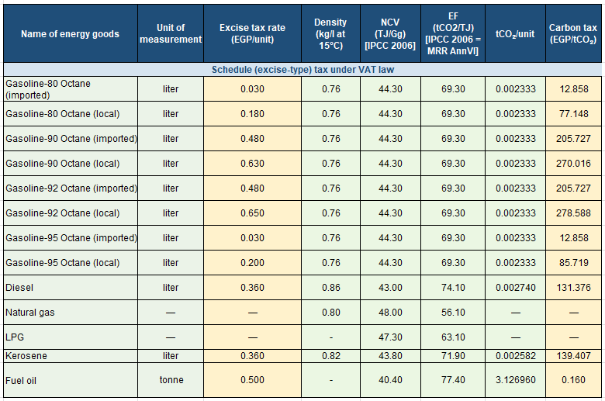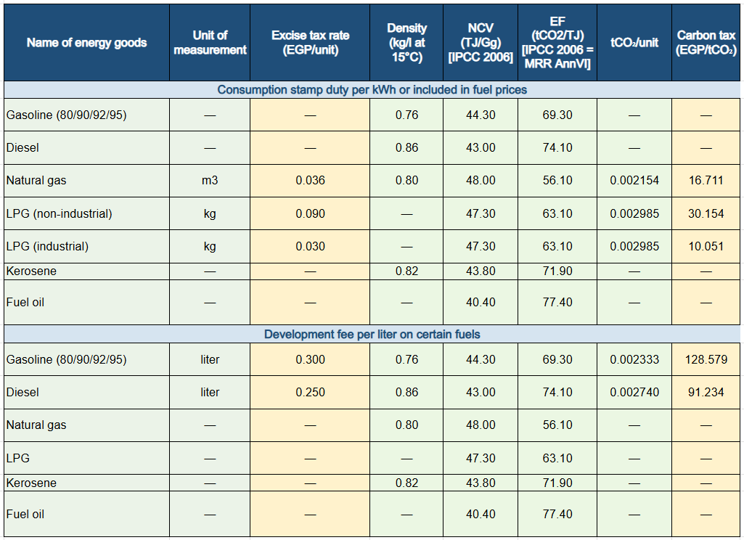
To align with CBAM requirements, the recalculated rates would need to be extended to cover fuels used in CBAM goods production. Egypt's current energy taxes impose high rates primarily on diesel and gasoline, which are not fuels used in the production of CBAM goods and thus not covered under the EU CBAM. Strengthening the existing excise tax system to include an explicit carbon tax on all fuels, such as natural gas and coal, would cover fuel-related emissions and a large share of CBAM financial obligations, as emissions from these fuels are subject to the financial CBAM requirement. Administrative and compliance costs would remain low by leveraging existing tax collection mechanisms and could be further reduced by consolidating all three existing fuel levies into one carbon fuel excise levy. An upstream carbon tax administration implies few points of regulation, limiting the number of entities responsible for collecting and delivering the tax due to the Government. Given CBAM’s phased implementation, a gradual transition to a domestic carbon fuel tax would allow a swift response to CBAM by covering fuel related emissions .

Expanding coverage to all industrial emissions
Emissions from non-combustion use in industrial processes can be large in the CBAM related sectors, in particular from calcination of limestone in cement production. However, apart from emissions from limestone in-put, non-combustion emissions in CBAM sectors to a large extent stem from the use of fossil fuels in the industrial processes. The EU Commission’s draft implementing regulation on carbon price paid recognizes the full price paid on fuels consumed by in the relevant CBAM industrial process, independently of if the standard emission factors at combustion has been used to calculate the fuel-based carbon levy.
A downstream carbon tax could be introduced, if also process emissions from other forms of input than fuels, such as limestone, are to be covered by a carbon pricing mechanism deductible from the CBAM financial obligation. Such a tax could be paid by the operators of the installations where the relevant industrial processes occur. Different administrative designs could be envisaged for collecting those revenues. To facilitate administrative and compliance costs, the operator could be required to pay a carbon tax on all emissions, both from fuels and other inputs. Instead of paying the upstream carbon fuel excise tax upfront and applying for compensation later, eligible businesses could obtain special licenses or exemptions allowing them to purchase fuel without the upstream carbon fuel excise levy if they demonstrate that they will pay a downstream carbon tax covering all actual emissions as calculated on the basis of applied MRV systems.
Default values could be used to facilitate compliance. Instead of requiring actual emissions calculations, the tax on these emissions could, if the operator prefers, be based on default values expressed in tons of CO₂e per ton of product (e.g., cement clinker). Such default values are for example used by the Intergovernmental Panel on Climate Change Emission Factor Database (IPCC). Firms that establish a facility-level MRV system could report verified lower emission intensities and claim rebates if their emissions fall below the default assumptions. This approach allows for immediate implementation by using default values, while incentivizing more accurate reporting and emissions reductions over time, with full MRV integration phased in over the medium to long term.
A downstream carbon levy on emissions at the facilities level could also be an option, when the MRV and regulatory capacity is present. In a hybrid approach accompanying an upstream carbon levy, the downstream carbon pricing instrument could focus on non-fuel or process emissions. This combined approach can add more complexity to the administrative system, though, and its success depends on the emissions reporting maturity of the facilities and whether enforcement capacity can be leveraged from other environmental regulations.

This paper was drafted by Carolyn Fischer, Stephen Stretton, and Susanne Aakerfeldt, with feedback and inputs from Adeel Abbas, Alexandra Campmas, Weronika Celniak, Hanan Elhadary, Dirk Heine, and Miguel Eduardo Sanchez Martin. The work was financed by UK SPEIG.
Official Journal of the European Union, “REGULATION (EU) 2023/956 OF THE EUROPEAN PARLIAMENT AND OF THE COUNCIL of 10 May 2023 establishing a carbon border adjustment mechanism,” May 16, 2023, https://eur-lex.europa.eu/legal-content/EN/TXT/PDF/?uri=CELEX:32023R0956
CBAM also including emissions from the production of heating and cooling used in the production processes, irrespective of the location of the production of the heating and cooling.
From 2026 to 2034, there will be a gradual phase-out of ETS free allowances for CBAM sectors. The CBAM factor is equal to 100 % for the period between the entry into force of that Regulation and the end of 2025, equal to 97,5 % in 2026, 95 % in 2027, 90 % in 2028, 77,5 % in 2029, 51,5 % in 2030, 39 % in 2031, 26,5 % in 2032 and 14 % in 2033. From 2034, no CBAM factor applies. The EU Commission is expected to present legislative proposals in July 2026 to align current EU ETS legislation with the 2040 EU climate goal, involving for example tightening the conditions for the free allocation of EU ETS allowances. It remains to be seen what effect these changes will have on the CBAM legislation.
See https://eur-lex.europa.eu/legal-content/EN/TXT/?uri=CELEX%3A52025PC0989.
See https://taxation-customs.ec.europa.eu/carbon-border-adjustment-mechanism/cbam-legislation-and-guidance_en#default-values-and-benchmarks-definitive-period
See https://eur-lex.europa.eu/legal-content/EN/TXT/?uri=OJ:L_202502547, and https://eur-lex.europa.eu/legal-content/EN/TXT/?uri=OJ:L_202502546.
https://eur-lex.europa.eu/legal-content/EN/TXT/PDF/?uri=OJ:L_202502620
See draft for public consultation 13 May until 10 June 2026 at June https://ec.europa.eu/info/law/better-regulation/have-your-say/initiatives/14830-Carbon-border-adjustment-mechanism-CBAM-carbon-price-paid-in-a-third-country_en.
CBAM Regulation (2023) Article 9 (4) as amended by CBAM Regulation Amendments (2025).
Maliszewska, Maryla., Carolyn Fischer, Euijin Jung, Maksym Chepeliev, 2025. “Carbon Border Adjustment Mechanism (CBAM) Exposure Indices – Methodological Note.” Prosperity Note. Washington, DC: World Bank.
https://worldsteel.org/data/annual-production-steel-data/?ind=P1_crude_steel_total_pub/EGY
https://www.trafigura.com/news-and-insights/press-releases/2026/trafigura-signs-term-sheet-for-the-development-of-new-aluminium-smelter-in-egypt/
https://aluminiumtoday.com/news/egyptian-2-billion-aluminium-plant-plan
See https://www.eu.dk/samling/20251/kommissionsforslag/KOM(2025)0989/forslag/2189723/3113874.pdf, Annexes 10 and 11.
https://climatepolicydatabase.org/policies/national-low-carbon-hydrogen-strategy
https://www.oecd.org/content/dam/oecd/en/about/programmes/cefim/green-hydrogen/2024-case-studies/Scatec-Egypt-case-study-2024.pdf
Alsharkas, Zeina, Jean Michel N. Marchat, Enrique Aldaz-Carroll, and Ana Goicoechea. 2026. Competing in the Face of Climate Risks: Evidence from Firms and Policy Priorities in MENAAP. Middle East, North Africa, Afghanistan, and Pakistan Development Report. Washington, DC: World Bank. doi: 10.1596/978-1-4648-2335-0.
Böhringer, Christoph and Dube, Isha and Fischer, Carolyn and Rutherford, Thomas, Border Carbon Adjustments Revisited (2026). CESifo Working Paper No. 12751, Available at SSRN: https://ssrn.com/abstract=6956665
CBAM Regulation (2023) Article 9, as amended by CBAM Regulation Amendments (2025).
CBAM Regulation (2023) Article 3 (29).
See Section 3.3.3 of Annex 1 to the draft Implementing Regulation of the carbon price paid, available at https://ec.europa.eu/info/law/better-regulation/have-your-say/initiatives/14830-Carbon-border-adjustment-mechanism-CBAM-carbon-price-paid-in-a-third-country_en.
See, for example, evidence for Cote d’Ivoire (Timilsina et al., 2023), Ghana (Elmaleh et al., 2021, p. 154f ), Pakistan (Burns et al., 2021), China and India (Carson et al., 2021), Iran (Mirhosseini et al., 2017), Spain (Markandya et al., 2013), Eastern Europe (Skrok et al., 2022, p. 48f), the EU (Barrios et al., 2013), and globally (Bento et al., 2018, Schoder, 2023).
Schoder (2021), Elmaleh et al. (2021), Skrok et al. (2022), Metcalf and Stock (2023).
ILO and IDB (2020), Hille & Moebius (2019), Moszoro (2021), Malerba and Wiebe (2021).
Timilsina and Sebsibie (2026)
Vandyck et al. (2018); Markandya et al. (2019); Scovronick et al. (2019); Weitzel et al. (2019); Rauner et al. (2020).
Heine & Black (2019).
See, for example, information on the Swedish carbon tax at https://www.government.se/carbontax and the UN Handbook on Carbon Taxation for Developing Countries, in particular chapters 6 and 8, for a presentation of its design and administration, at https://desapublications.un.org/publications/united-nations-handbook-carbon-taxation-developing-countries.
Agnolucci, Paolo, Carolyn Fischer, Dirk Heine, Mariza Montes de Oca Leon, Joseph Pryor, Kathleen Patroni, Stéphane Hallegatte. 2023. “Measuring Total Carbon Pricing”. The World Bank Research Observer. https://doi.org/10.1093/wbro/lkad009 and Campmas, A., Gill, S., Al-Rikabi, J., Bastidas, D. Forthcoming. PFR Fundamentals: Total Carbon Price 2.0. World Bank.
The South African Carbon Tax Act makes use of such default values for calculating taxable emissions from industrial processes, see https://lawlibrary.org.za/akn/za/act/2019/15/eng@2019-05-23#att_1__subpart_nn_3.

